INFORMATION TECHNOLOGY AND MUNICIPAL AUDIT OUTCOMES: DOES INFORMATION TECHNOLOGY SUPPORT ACHIEVEING A CLEAN AUDIT REPORT?

Abstract:
This paper investigates the municipal audit outcomes and compares the results with the distribution of financial management and internal control systems in South African municipalities. It employs a qualitative research study, using document analysis techniques. The major sources of information are the consolidated general reports on the audit outcomes of local government during the last five reporting periods, together with applicable legislation and regulations.
The impact of Information Technology as one of the possible causes or solutions for the adverse audit reports which municipalities receive year after year is further compared to the distribution of financial management and internal control systems across municipalities to identify trends, without consideration of the role of skilled staff and rigorous processes, or the support provided by external consultants and system vendors.
The paper concludes that whilst trends have been identified that call for additional research and analysis, the distribution of systems alone do not determine the achievement of a clean audit report even though a pattern has been identified from the research, which indicates that it does make a contribution in this respect.
The Auditor-General provides recommendations to address the IT related audit findings, amongst other standardisation of IT governance; best practice manuals; policies and procedures; the systems; and management of vendors. These recommendations, together with enabling legislation and regulations, pave the way for a standardised minimum system specification for municipalities.
Key words: Information technology, Financial management and internal control systems, Audit outcomes

Background
Municipalities “function as a fully-fledged level of government in its own right, and are the closest to the citizens of the country”, (Alberts, 2011). Their purpose is to provide services to the citizens and business in a sustainable manner, with Information Technology (IT) an enabler of these services.
The Municipal Structures Act, (South Africa, 1998) divides municipalities into Category A metropolitan municipalities; Category B local municipalities; and Category C district municipalities. Local government currently consists of 8 metropolitan municipalities, 44 district municipalities and 205 local municipalities, 257 municipalities in total after the elections of August 2016, and 278 before. The functions and responsibilities of municipalities are stated in schedules 4B & 5B of the constitution, (South Africa, 1996). Government has set specific minimum standards and service delivery targets for municipalities across the country. These can be summarised as follows:
Table 1: Minimum standards for basic municipal services
Service | Target
Water | All households to have access to clean piped water within 200 m from the household.
Sanitation | All households to have access to a ventilated pit latrine on site.
Electricity | All households to be connected to the national grid.
Refuse removal | All households to have access to a weekly removal service.
Housing | All existing informal settlements to be formalised with land-use plans for economic and social facilities and with provision of permanent basic municipal services.
Other services | Standards for access to all other services must be clearly defined, planned and where possible, implemented.
Source: (Shai & Mhemhe, 2010)
Whilst steady progress has been made towards significant social and economic development and financial management reforms, service delivery protests have been escalating, partly due to expectations being created by national government that local government cannot fulfill. “Persisting apartheid-era spatial segregation patterns require large subsidies, and poor households face disproportionate cost to access services and opportunities. At the same time, the current pace of urban population growth is outstripping economic growth, and the urban economic growth rate has failed to deliver required jobs,” (Nagooroo, 2011). The failure of municipalities to deliver on service delivery targets are echoed in reports by newspapers, academics, government stakeholders and the Auditor-General (AG). Dlamini (2014) reports on the best and worst municipalities, determined by unemployment rates, proportion of residents above 20 who have passed grade 12, the poverty rate, houses owned but not fully paid, access to the four basic municipal services and municipal debt. The article posits that “high debt is an indication of poor revenue collection” which is ascribed to “lack of political backing, insufficient staff or capacity and unwillingness to perform service cut offs to enforce payment”.
Molatlhwa (2016) continues this discourse by stating that whilst “municipalities spent more than R3.3-billion of taxpayers’ money on consultants, … it was the AG’s office that had to correct their material mistakes”. The author continues that “R615-million was spent on consultants for IT services, R43-million for preparation of performance information and R1.822-billion for other services”. Given these levels of spending, the question arises, is there a relationship between services provided to citizens and business, a specific Financial Management and Internal Control System (FMICS), and the audit outcome a municipality achieves?

Methodology
This paper is based on a qualitative research study, using documents for gathering and analysing of information, identification of trends and establishment of relationships.
Documents provide a source of data other than observations, interviews and questionnaires. Oates (2011, p. 233) distinguishes between found and researcher generated documents, being that found documents existed before the research commenced and research generated documents were constructed solely for the purposes of the research task. Other than the consolidated municipal audit reports of the AG, legislation, academic works, industry reports and conference papers were consulted. Two broad research approaches have been adopted, which are explained by Oates (2011, p. 239) as analysing documents as vessels and objects:
Documents as vessels are seen as receptacles containing data and content analysis can be qualitative (examining the different topics and themes covered within the documents) and quantitative (counting the number of times themes occur in a document).
Documents as objects are treated as entities on their own. The review in this context focuses on who produces these, who uses them and how same are developed, exchanged and circulated.
Documents are viewed as vessels and both qualitative and quantitative methods are applied to discover themes relating to audit qualifications which are related to municipal IT systems, and then counting the number of times which these themes are repeated within a particular audit report, and across audit reports. The findings were then compared with similar found documents, after establishing their appropriateness, credibility, reliability, possible bias and recognition of limitations in their use. Thus, the consolidated municipal audit reports were used as departure point for preparation of this paper, and supplemented with applicable legislation, academic works, industry reports and conference papers to collect information in search of a relationship between the use of a specific FMICS and the audit outcome which the municipality achieved.

Analysis of research findings
In his address on 14 July 2009, launching Operation Clean Audit 2014, the late Minister for Cooperative Governance and Traditional Affairs, Honourable Sicelo Shiceka set the strategic vision and the objectives of the initiative for all municipalities to achieve clean audit reports on their financial statements by 2014 (Staff Reporter, 2009). The following table provides a summary of the audit outcomes achieved since the inauguration of the initiative:
Table 2: Summary of audit outcomes
Audit outcomes | Number of municipalities
 | 2014/ 2015 | 2013/ 2014 | 2012/2013 | 2011/2012 | 2010/2011 | 2009/2010 | 2008/2009
Financially unqualified with no findings on predetermined objectives or compliance with laws and regulations (clean audit report). | 54 | 40 | 22 | 9 | 13 | 7 | 4
Financially unqualified with findings on predetermined objectives and compliance with laws and regulations. | 109 | 110 | 138 | 106 | 114 | 122 | 107
Source: Researcher (2016)
The audit referred to above, covers an external review of the financial position of a municipality, performance against predetermined objectives which were set by the municipality itself and an IT review.
During the review of the 2010-11 financial year, the AG provided an overview of IT systems management, and the IT employed by municipalities, (Auditor-General, 2011). The report noted that 191 municipalities used 57 different financial and payroll systems which ranged from “computer packages bought off-the-shelf “ to custom developed systems. “The management and support of these systems take place independently, with each municipality managing its own systems with little or no support apart from the system vendors”. The AG reviewed and reported on IT management roles and responsibilities; control and management weaknesses; and the root causes of deficiencies. Significant IT weaknesses were identified in the areas of IT governance; Security management; User account management; and IT service continuity. The section on IT management as a specific driver of audit outcomes concludes that “municipal management started to implement IT controls during the 2010-11 financial year. Fresh commitments to address the root causes of IT weaknesses have been received from most of the municipalities, and oversight structures should monitor progress as part of the Operation clean audit drive”, (Auditor-General, 2011).
The General report on the audit outcomes of Local Government 2011-12 (Auditor-General, 2012), indicates four recurring findings which contribute towards adverse municipal audit reports, namely: Key role players not providing assurance; Drivers of key controls which are not improving; Root causes which are not being addressed; and Key risk areas which are not receiving required attention. The report continues by unpacking each of these in detail, and identifies areas of concern within IT management as being:
- The status of information within Local Government:
- Confidentiality
  - Security management
  - IT Governance
  - User access control
- Integrity
- Security management
- User access control
- Availability
- Security management
- IT Service continuity
- The status of key enabling controls:
- Good governance
- Effective management
- Secure architecture and infrastructure
The AG contends that most municipalities are experiencing challenges with the design of controls and many have not begun to deal with implementation and sustained effectiveness thereof. At a minimum, management should design IT controls that would address the threats and weaknesses identified in vulnerability assessments. Particular attention should be given to the threats and weaknesses that would have an impact on the confidentiality, integrity and availability of data, which recommendation is aligned to the Protection of Personal Information Act (South Africa, 2013). Once the IT controls have been designed, management should ensure that they are implemented and embedded in IT processes and systems. Attention is also required to ensure that staff across the municipality are aware of, and understand the IT controls being implemented, as well as their roles and responsibilities in this regard. Management should ensure that the IT controls that have been designed and implemented are functioning effectively at all times, and should sustain these IT controls through disciplined and consistently performed daily, monthly and quarterly IT operational practices and reviews.
These audit findings should be considered in response to the Operation clean audit operational plan which was presented by the AG on 3 April 2012, indicating that IT compliance and performance is an area of grave concern across local government. The operational plan which was presented highlights, amongst other, Leadership; Financial and performance management; and Governance, including IT governance, as areas requiring intervention to achieve clean audit reports. However, the consolidated municipal audit report for the period 2012-13 once again mentions IT governance; Security management; User access management; IT service continuity; and Formal control over IT systems as the root causes for adverse audit findings (Auditor-General, 2013). The report cites a lack of skills and budget constraints, deficient service level agreements with system vendors and inadequate support, as inefficiencies which exacerbate the identified challenges.
The woes of municipalities continue during the periods 2013-14 and 2014-15, with Radebe (2014) commenting that Operation clean audit should be viewed as a journey and not a once off target, with only 5% of municipalities achieving clean audits in 2013-14. In this period, the AG report highlights five areas of concern that require external intervention to resolve, IT management and controls being one of these. The AG again cautions in 2014-15 (Auditor-General, 2015) that “attention should be given to the qualifications and experience of CIOs and IT managers”, in addition to addressing the findings from previous years and paying attention to emerging risks, naming electronic fund transfers and readiness for implementation of the Standard Chart of Accounts for Municipalities (mSCOA), in particular.
Figure 1: Frequency of IT related audit findings arranged per theme, for the audit periods 2010-11 to 2014-15

Source: Researcher (2016)
An analysis of the consolidated audit reports on local government for the past five years further reveals that the following municipalities received clean audit outcomes:
Table 3: Municipalities achieving clean audit reports during the past five years
Municipality | IT System | 2014/15 | 2013/14 | 2012/13 | 2011/12 | 2010/11
E CAPE:
Joe Gqabi DM | K | √
Sarah Baartman DM | E | √ | √
Ngquza Hills LM | F | √
Matatiele LM | A | √
Senqu LM | M | √ | √
FREE STATE:
Thabo Mofutsanyana DM | E | √
GAUTENG:
Ekurhuleni MM | D | √ | √
Sedibeng DM | D | √ | √ | √
Midvaal LM | D | √ | √
Mogale City LM | B | √ | √
KZN:
eThekwini MM | E | √
iLembe DM | F | √ | √
uMgungundlovu DM | J | √ | √
Uthungulu DM | D | √ | √ | √
Umzinyathi DM | F |  |  |  |  | √
Zululand DM | D | √ | √
Dannhauser LM | F |  | √
eMadlageni LM | J |  |  |  |  | √
Emnambithi/ Ladysmith LM | K |  | √
Ezinqoleni LM | J | √ | √
Hibiscus Coast LM | F | √
Mandeni LM | J | √ | √
Msinga LM | C | √ |  | √
Msunduzi LM | H | √
Nquthu LM | M | √
Ntambanana LM | D |  |  | √
Okhahlamba LM | J | √ |  | √
Richmond LM | A |  | √ |  |  | √
Ubuhlebezwe LM | K | √ | √ | √
Umdoni LM | K | √ |  |  |  | √
Umhlabuyalingana LM | A | √
uMhlathuze LM | H | √ | √ | √
Umtshezi LM | D |  |  |  |  | √
uMuziwabantu LM | A | √
uMzimkhulu LM | F |  | √ | √ | √
Umzumbe LM | J | √ | √
LIMPOPO:
Waterberg DM | F |  |  |  | √ | √
Fetakgomo LM | F |  |  |  |  | √
MPUMALANGA:
Ehlanzeni DM | D | √ | √ | √ | √ | √
Gert Sibande DM | F |  |  |  |  | √
Nkangala DM | F | √
Steve Tshwete LM | E |  | √ | √ | √ | √
Victor Khanye LM | M |  |  |  |  | √
N CAPE:
Frances Baard DM | D | √ | √
ZF Mgcawu DM | K | √ | √ | √
W CAPE:
City of Cape Town | L | √ | √ | √
Cape Winelands DM | K | √ | √
Eden DM | A | √ | √
Overberg DM | K | √
West Coast DM | K | √ | √ | √ | √ | √
Bitou LM | K | √ | √
Breede Valley LM | K | √ | √ | √
Cape Agulhas LM | K | √ | √
Drakenstein LM | N | √ | √
George LM | K | √ | √ | √ | √
Hessequa LM | D | √ | √
Knysna LM | I | √ | √ | √
Langeberg LM | I | √ | √ | √ | √
Matzikama LM | H | √
Mossel Bay LM | I | √ | √ | √ | √
Overstrand LM | K | √ | √ | √
Saldanha Bay LM | K | √
Stellenbosch LM | K | √
Swartland LM | I | √ | √ | √ | √ | √
Swellendam LM | K | √
Theewaterskloof LM | A | √ | √ | √
Witzenberg LM | K | √ | √ | √
 |  | 54 | 40 | 22 | 9 | 13
Source: Researcher (2016)
It is clear from the reports of the AG that IT has both a direct and indirect impact on achieving a clean audit report, in terms of enabling municipal operations and financial management, but more importantly in the management of municipal information, provision and maintenance of enabling controls, and instrumentality in terms of corporate governance. An analysis of the distribution of FMICS across municipalities achieving clean audit reports, provides evidence of a correlation:
Table 4: Distribution of FMICS across municipalities
System | Market share (before elections) |  | Clean audits
 | Number | Percentage | Number | Percentage
A | 19 | 6.8 | 6 | 9.0
B | 2 | 1.0 | 1 | 1.5
C | 3 | 1.0 | 1 | 1.5
D | 67 | 24.1 | 10 | 15.1
E | 8 | 2.8 | 3 | 4.5
F | 42 | 15.1 | 10 | 15.1
G | 5 | 1.7 | 0 | 0
H | 11 | 3.9 | 3 | 4.5
I | 15 | 5.3 | 4 | 6.0
J | 34 | 12.2 | 6 | 9.0
K | 31 | 11.1 | 17 | 25.7
L | 4 | 1.5 | 1 | 1.5
M | 35 | 12.5 | 3 | 4.5
N | 2 | 1.0 | 1 | 1.5
 | 278 |  | 66
Source: Researcher (2016)
A graphic presentation of the above distribution clearly indicates that, for most of the FMICS listed above, there is a close correlation between the percentage market share and the percentage clean audits achieved by municipalities using the system.
Figure 2: Distribution of FMICS based on market share and clean audit outcomes
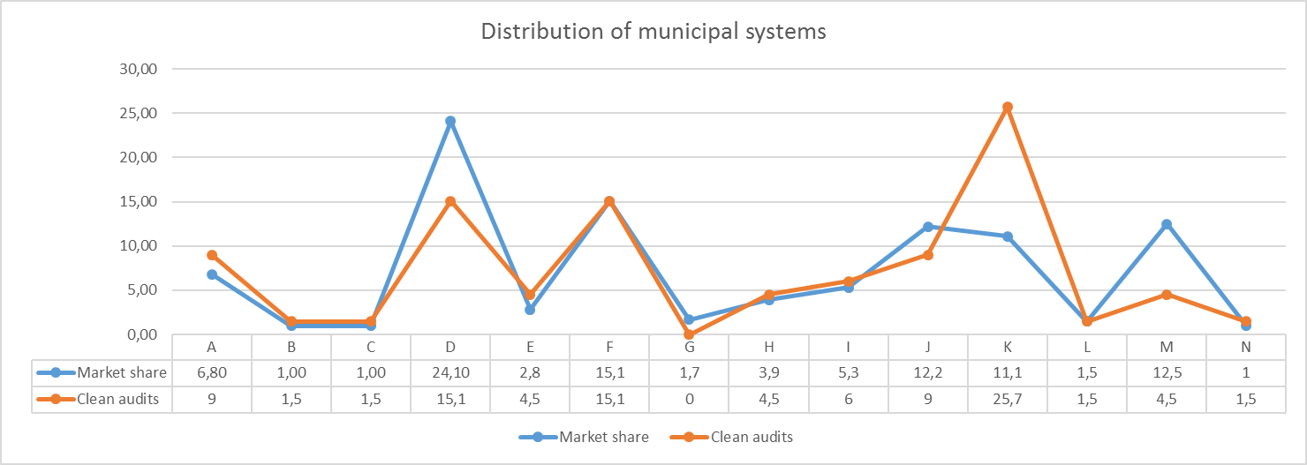
Source: Researcher (2016)
In the case of systems D, K and M however, there is a significant deviation which calls for further analysis.
Table 5: Comparison of FMICS market share and clean audit outcomes
System | Market share (%) | Clean audits (%) | Variance
D | 24.1 | 15.1 | -9.0
K | 11.1 | 25.7 | +14.6
M | 12.5 | 4.5 | -8.0
Source: Researcher (2016)
Table 5 above indicates that although systems D and M have a market share of 24.1% and 12.5% each, municipalities using these systems only represent 15.1% and 4.5% of those which could achieve a clean audit outcome, a variance of 9.0% and 8.0% respectively. On the other hand, whilst system K only commands a market share of 11.1%, their user municipalities represent 25.7% of clean audit outcomes achieved. These deviations call for further research to confirm if this finding is related to the specific system only, or was influenced by other factors such as people, processes and the relationship with the system vendor.
The geographic distribution of municipalities using these systems and achieving clean audit outcomes, also presents an interesting pattern:
Figure 3: Geographic distribution of municipalities achieving clean audit outcomes (2014/ 2015 only) and using systems D, K or M
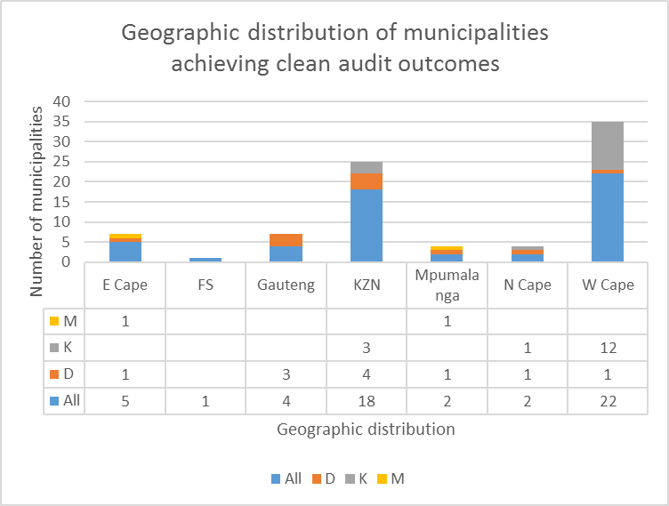
Source: Researcher (2016)
Dlamini (2014) lists the top 10 performing municipalities in the country, 7 of which are from the Western Cape, 2 from the Northern Cape and 1 from KwaZulu-Natal. This research relates to the audit outcomes, the 2011 census and related information published by National Treasury, and correlates with the notion of a geographic impact on audit outcomes.
The AG provides guidance to municipalities to address and resolve the audit findings, amongst other that:
- A uniform IT governance framework should be developed and rolled out to all municipalities;
- An IT best practice manual or guideline should be drafted for municipalities;
- Policies and procedures should be centrally developed to address the control weaknesses;

- External stakeholders such as CoGTA, SALGA and District Municipalities should support and capacitate IT functions within municipalities;
- A working group should be established to assist the municipalities in addressing the root causes of audit findings;
- IT governance forums should be established;
- Internal audit and audit committees should play a more effective role in tracking progress made with implementation of corrective measures to address IT audit findings;

- Management should institute consequence management;
- Management should reprioritise budget allocations to provide for the implementation of disaster recovery plans and backup procedures;
- Management should reallocate sufficient budget for the upskilling of IT staff;

- Consultants should be monitored and managed through service level agreements (SLAs);
- Staff should be up-skilled by the consultants performing services; and
- More standardisation should take place at the municipalities with regards to the IT systems used and the vendors that support these systems.

Table 6: Analysis of the recommendations for improvement of audit outcomes
Recommendation | Standardisation | People and capacity building | Policies and processes | External support and intervention
i | √ |  | √
ii | √ |  | √
iii | √ |  | √
iv |  | √ |  | √
v |  | √ |  | √
vi | √ |  |  | √
vii |  | √
viii |  | √ | √
ix |  | √ | √
x |  | √
xi |  | √ | √
xii |  | √ |  | √
xiii | √
Total | 5 | 8 | 6 | 4
Source: Researcher (2016)
Although standardisation only features in 5 of the 13 recurring recommendations of the AG, it would also support people and address capacity of people to execute their duties; is closely related to policies and processes, and a call for central development thereof; and relates to the proposed external support or interventions which are required.
Section 216(1) of the Constitution (South Africa, 1996) states that national legislation must establish a National Treasury which should prescribe measures to ensure both transparency and expenditure control in each sphere of government, by introducing, amongst other; Generally Recognised Accounting Practice (GRAP); Uniform expenditure classifications (SCOA); and Uniform treasury norms and standards. This is for all three spheres of government and is not limited to financial measures only.
The Municipal Finance Management Act, (South Africa, 2003), Section 168(1) provides that the Minister (of Finance), acting with the cabinet member responsible for local government, may promulgate regulations for, among other, any matter that may be prescribed and any other matter that may facilitate the enforcement and administration of this act, being the Municipal Finance Management Act. To this effect the minister has already embarked on a budget reform programme which will culminate in a national standard for the uniform recording and classification of municipal budget and financial information (SCOA) and which will enable uniform information sets across the whole of government, including local government, for the purposes of national policy coordination and reporting, benchmarking and performance measurement. (South Africa, 2014) This reform will also introduce a standard FMICS specification and minimum business processes for local government, both of which will support the recommendations of the AG, and ultimately enable the achievement of clean audit reports across local government.
ISO/IEC 38500 provides an internationally accepted standard for governance of IT. It proposes a framework to assist organisations (including municipalities) to understand and fulfill their legal, regulatory, and ethical obligations and is applicable to organisations of all sizes, including public and private companies, government entities, and not-for-profit organisations. The framework for sound IT governance which is proposed in the ISO/IEC 38500 standard includes three main tasks, which can be represented as follows:
Figure 4: Application of ISO/IEC 38500 main tasks
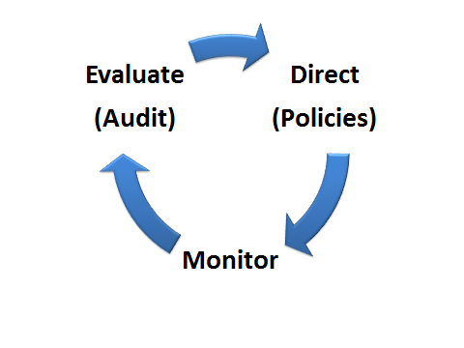
Source: Researcher (2017)
The ISO standard further proposes six guiding principles for good governance of IT, which can be applied to municipalities as follows (Van Haren Publishing, 2015):
- Responsibility - Employees know their responsibilities in terms of demand and supply of IT and have the authority to meet these. The knowledge (skills) and authority (governance, policies and procedures) are addressed in the recommendations of the AG. Mention should also be made of the necessary resources to action these responsibilities;
- Strategy - Municipal strategies and objectives should be aligned with IT possibilities, and all IT within the municipality should support these (best practice manuals, policies and procedures). Municipal strategies and objectives are captured in the Integrated Development Plan (IDP), provided for in the annual budget (resource allocations) and monitored in line with the Strategic Development and Budget Implementation Plan (SDBIP);
- Acquisition - IT investments must be made on the basis of a business case with regular monitoring in place to assess whether the assumptions still hold and the objectives are being achieved (IT governance forums, internal audit and audit committees);
- Performance - The performance of IT systems should lead to business benefits and therefore it is necessary that IT supports the municipality properly. The performance of IT should be measured and reported (SLAs), and directly related to the direct and indirect business benefits being achieved;
- Conformance - IT systems should help to ensure that business processes comply with legislation and regulations, and therefore IT itself must also comply with legal requirements, regulations and agreed internal processes (standardisation); and
- Human behaviour - IT policies, practices and decisions respect human behaviour and acknowledge the needs of all the people in the process. Sufficient skills transfer and capacity building within municipalities should be provided. Key IT decisions should be documented and continuity planning maintained to cater for human weakness/ failure (consequence management).
Therefore, it is posited that the six guiding principles for good governance of IT which are provided by the ISO standard present a framework for municipalities to address existing audit findings related to IT management, and that these should be incorporated into the daily practises of the municipality to contribute towards the achievement of clean audit reports going forward, over and above the benefits which would emanate from standardisation of systems and their specifications.
Recommendations and conclusion
The research paper investigates the distribution of different FMICS across the municipal environment in relation to the achieved audit outcomes, recommendations of the AG, legislation and guidance provided by ISO/IEC 38500.
The consolidated general reports on the audit outcomes of Local Government for the last five years were considered to identify IT related audit findings and together with the six guiding principles for good governance of IT from ISO/ ISEC 38500, these reports provide recommendations to improve the audit outcomes in municipalities, namely:
- Development of a standard IT governance framework for municipalities;
- Development and roll out uniform IT best practice manuals for municipalities;
- Development of uniform IT policies and procedures for municipalities;
- External support and capacity building for IT functions in municipalities;
- Working groups to assist with addressing root causes of adverse audit findings;
- Establishment of IT governance forums;
- Internal audit functions and committees to track implementation of corrective steps;
- Consequence management;
- Budget allocations to address disaster recovery and back up facilities;
- Budget allocations for up skilling of IT staff;
- Standardisation of systems and vendor SLAs for municipalities; and
- Standard system specifications for municipalities.

The comparison of clean audit outcomes and the distribution of FMICS across the municipal environment, and the geographic distribution of municipalities achieving clean audit outcomes, present a correlation which calls for further analysis to conclusively prove the existence of a positive relationship. The recommendations above could be used as the evaluation criteria for the analysis of individual systems.
The legislative framework, namely the Constitution, Municipal Finance Management Act, and recently the regulation of a Standard Chart of Accounts for Municipalities, as part of the greater budget reform programme of National Treasury, propose a standard FMICS specification and minimum business processes for local government, to address the current situation, and in response to the recommendations of the AG.
It is recommended as an outcome of this paper that the above analysis of audit findings, together with the deviations in market - and geographic distributions thereof, be further researched to identify the impact which individual FMICS have on the published audit reports.

REFERENCES:
Alberts, L. (2011, September/ October). Overview of Local Government in SA. Service Leadership in Local Government, Issue 39.
Auditor-General. (2011). Consolidated General Report onthe Audit Outcomes of Local Government 2010-11. Retrieved from http://www.agsa.gov.za
Auditor-General. (2012). General Report on the Audit Outcomes of Local Government 2011-12. Retrieved from http://www.agsa.gov.za
Auditor-General. (2013). Consolidated General Report onthe Audit Outomes of Local Governmment 2012-13. Retrieved from http://www.agsa.gov.za
Auditor-General. (2015). Consolidated General Report on the Audit Outcomes of Local Government 2014-15. Retrieved from http://www.agsa.gov.za
Dlamini, P. (2014, May 21). Tale of Best and Worst SA Councils. The Times, p. 4.
Molatlhwa, O. (2016, June 2). Consultants a R3bn Joke. The Times, p. 4.
Nagooroo, C. (2011, Summer). Key Note Address by Mr Chris Nagooroo - President of IMFO at the Launch ofthe Audit and Risk Indaba held on 27-28 October 2011. IMFO Volume 12 Number 2.
Oates, B. (2011). Researching Information Systems and Computing. London: Sage.
Radebe, S. (2014). Clean Audit 2014: Are We Getting There? Sandton: Grant Thornton.
Shai, J., & Mhemhe, M. (2010, Winter). Service Delivery in South Africa - Are we there yet? IMFO Volume 11 Number 4.
South Africa. (1996, May 8). Constitution of the Republic of South Africa, Act 108 of 1996, as adopted by the Constitutional Assembly on 8 May 1996 and as amended on 11 October 1996. Retrieved August 10, 2015, from http://www.gov.za
South Africa. (1998, December 18). Municipal Structures Act, Act 117 of 1998. Retrieved from South African Government: http://www.gov.za
South Africa. (2003). Municipal Finance Management Act, Act 56 of 2003. Retrieved from http://www.gov.za
South Africa. (2013). Protection of Personal Information Act, Act 4 of 2013. Retrieved from http://www.gov.za
South Africa. (2014, April 22). Muicipal Regulations on a Standard Chart of Accounts. Governtment Gazette 37577. Pretoria: National Treasury.
Staff Reporter. (2009, Spring). "Operation Clean Audits by 2014" Launched to Achieve Clean Governance and Improve Service Delivery. IMFO Volume 10 Number 1.
Van Haren Publishing. (2015, March 10). ISO IEC 38500 for IT Governance in 3 Minutes. Retrieved from http://www.vanharen.net/blog

