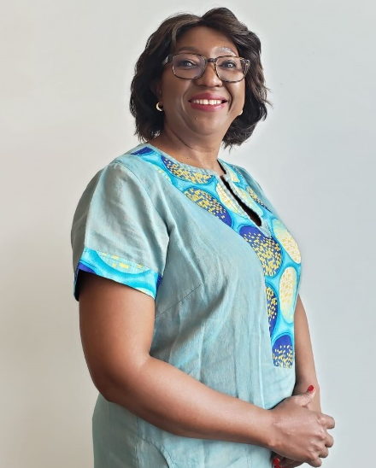 | Bongi Kunene  Standard Bank  Ms. Bongi Kunene is the Pan African Public Sector Banking Head for Standard Bank Group. She is responsible for public sector banking in 15 African countries. Prior to this position she was the Executive Director at the Board of the World Bank Group representing the governments of Angola, Nigeria and South Africa. Ms Kunene is a development finance specialist who has experience in driving government policies and programs. She has been a banker and civil servant. Among her previous roles she has been head of a provincial treasury, a senior advisor and a sous Sherpa in the G20. She has served in a number of boards.

