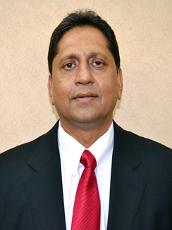 | Dr Krish Kumar  eThekwini Metro Municipality  Dr Krish Kumar has a PHD in Administration, Batchelor of Commerce degree in Accounting, a Masters in Administration, a Management Development (MDP) certificate, and has completed the Minimum Competency Training prescribed by National Treasury for CFO’s.  He has presented papers at various conferences and participated in study tours worldwide, including the USA, Canada, South America, UK, India, Far East, Australia, New Zealand, and throughout Africa. On behalf of the World Bank he also undertook a study of the state of local government finances in Tanzania as part of the assessment of a loan application made by Tanzania. Last year he delivered three training courses to the C40 cities climate leadership group in Jordan. He has 38 years local government experience and has been the Chief Financial Officer (CFO) of the Ethekwini Municipality (Durban, South Africa) since 1997 (21 years).  He is currently also a member of South African Local Government Association Finance Working Group, Chairperson of the Metro Chief Finance Officer’s (CFO) Forum for CIGFARO, a Commissioner on the Financial & Fiscal Commission (FFC), C40 Board member and member of the Accounting Standards Board for two terms. He is also the Past President of CIGFARO, as well as a Fellow of the Institute.

