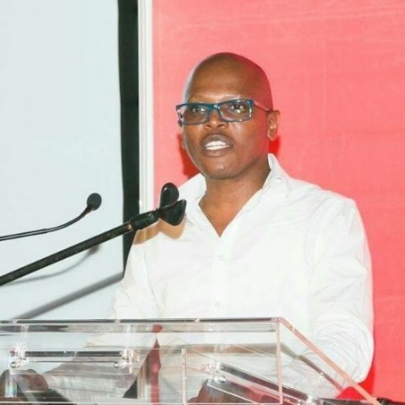 | Molefe-Isaac Fani  National Treasury  Molefe-Isaac started his career as a Chemical Engineer at Sasol Chemical Industries (SASOL) in Sasolburg. His love for processes and quality assurance systems resulted in him working for Alusaf in Richardsbay as Process Specialist responsible for commissioning of a new Aluminum Smelter. He later joined Eskom and rose in the ranks in the engineering and operations.  When Eskom took a decision to bring back the mothballed power stations, Molefe-Isaac took the opportunity and became the Commercial manager at Grootvlei Power station. That resulting in him having to look at different processes and business models in the Supply Chain and contracting to ensure smooth return to service of the station. His fascination with business processes and business enhancements was further sparked by working for CSIR, Gauteng Provincial Treasury, and now the National Treasury, as Chief Director in Transversal Sourcing. He has a qualification in engineering and a Master of Commerce (MCom) in Business Management. He is currently a PhD student at Da Vinci Institute.

