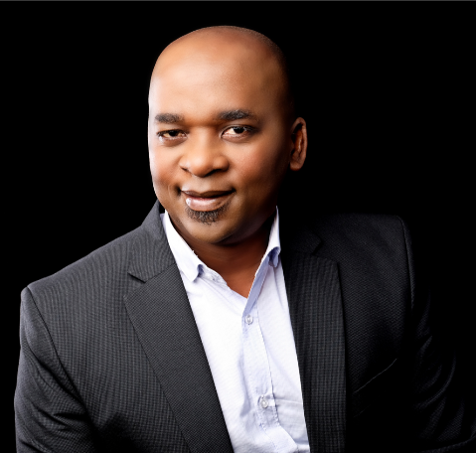 | Musa Makhunga  HR Matters  Musa is the Founding Managing Director of HR Matters (Pty) Ltd, a strategic human resources leadership firm and HR Matters Properties (Pty) Ltd, with about 18 years’ experience in Corporate SA Inc. as a Human Resources Professional in sectors including: education, manufacturing, mining, banking, retail and development finance, latterly (past 12 years) in HR Consulting and Provision of Warehousing and distribution services.

