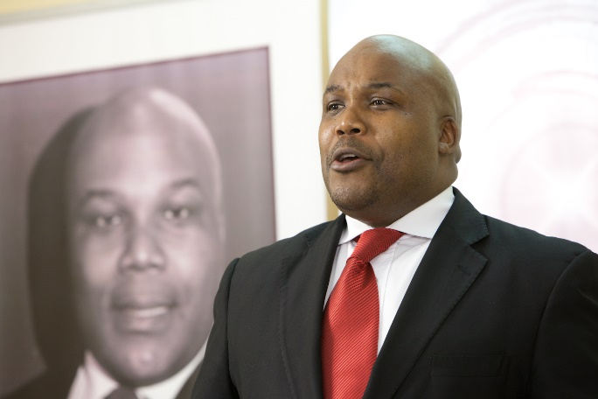 | Umbusi Ziqalo  Resilience Group  Umbusi Ziqalo is a Thought-Leader, Researcher, a Coach and Mentor in Transformational Leadership. He is a Specialist in Individual, Team and Organisational Leadership. He is well renowned as Premier Corporate Speaker, Conference Panelist, a Prolific Author, an Erudite, a Master Teacher and Facilitator of Personal Mastery. He is a Systems Thinker and a Modern Philosopher in the Ecosystem of Ubuntu Way of Life.  Ziqalo is a Thought-Leader, a Disruptor and a Historian, a Creator of New Pathways. He is the Founder and CEO of Resilience Group, a Company which he founded in 2005. He also founded other Companies and Organisations which are Subsidiaries of Resilience Group, such as Resilience Leadership Institute, Umbusi Thought Leadership Co., Ignite Careers Laboratory and Gladiator City Shuttle.

