WESTERN PROVINCE MASTERS ATHLETICS ASSOCIATION
NITIDA WINE ESTATE (S.A.M.A. AWARDS FUNCTION & DINNER/DANCE) : 5 maps provided on pages 61,45,44,43 & 42.
From the direction of Paarl/Cape Town City Bowl on the N1, exit the N1 on the off-ramp into the R302 (Durban Rd./W.van Schoor Ave.) and turn left at the 1st. set of robots into Mispel St. and then proceed down past Bellville Athletics Stadium and at the robots turn right into Charl Cronje Drive (with Tyger Valley Shopping Centre on the right) until it eventually becomes Tygerbergvalley(vallei) Road (M31).
When you eventually reach the T-junction with the M13 (Tygerberg Road), turn left and continue along past the D'Aria Conference Centre/Populars Restaurant, past Bloemendal Restaurant/Wine Estate and Maasstrecht Wines until you reach Nitida Wine Estate on the right at the top of the rise.
Alternatively from the Milnerton/ Table View/ Bothasig direction, pass the Caltex Refinery and proceed along Plattekloof Road and at the circle turn left in direction of the M13 (also Tygerberg Road), past the Durbanville Hills and Hillcrest Wine Estates and again at the top of the rise, turn left into Nitida Wine Estate.
COORDINATES ON ATTACHED MAP :
BQ 44 (page 44 on map)

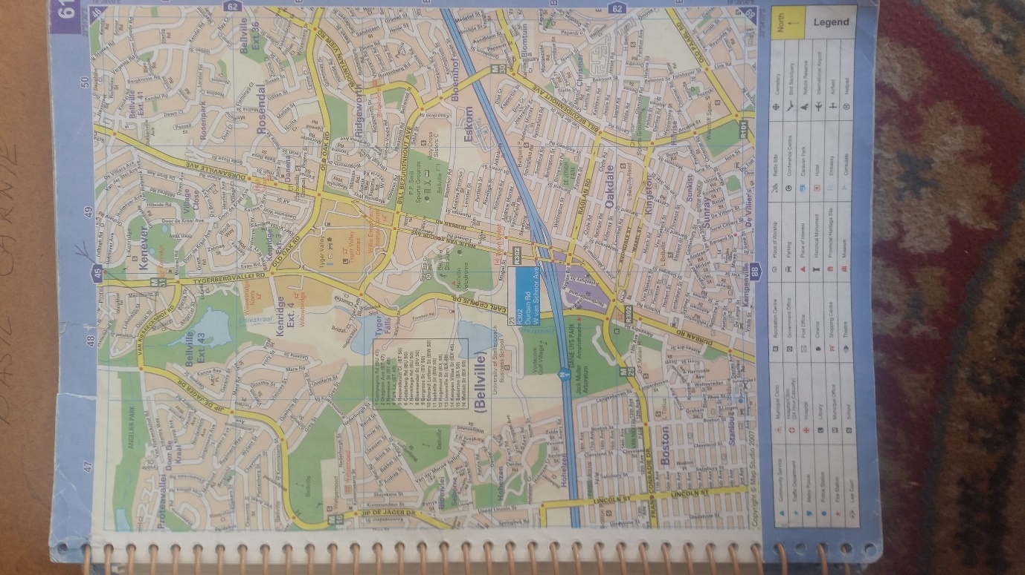
MAP 1: Nitida Wine Estate.

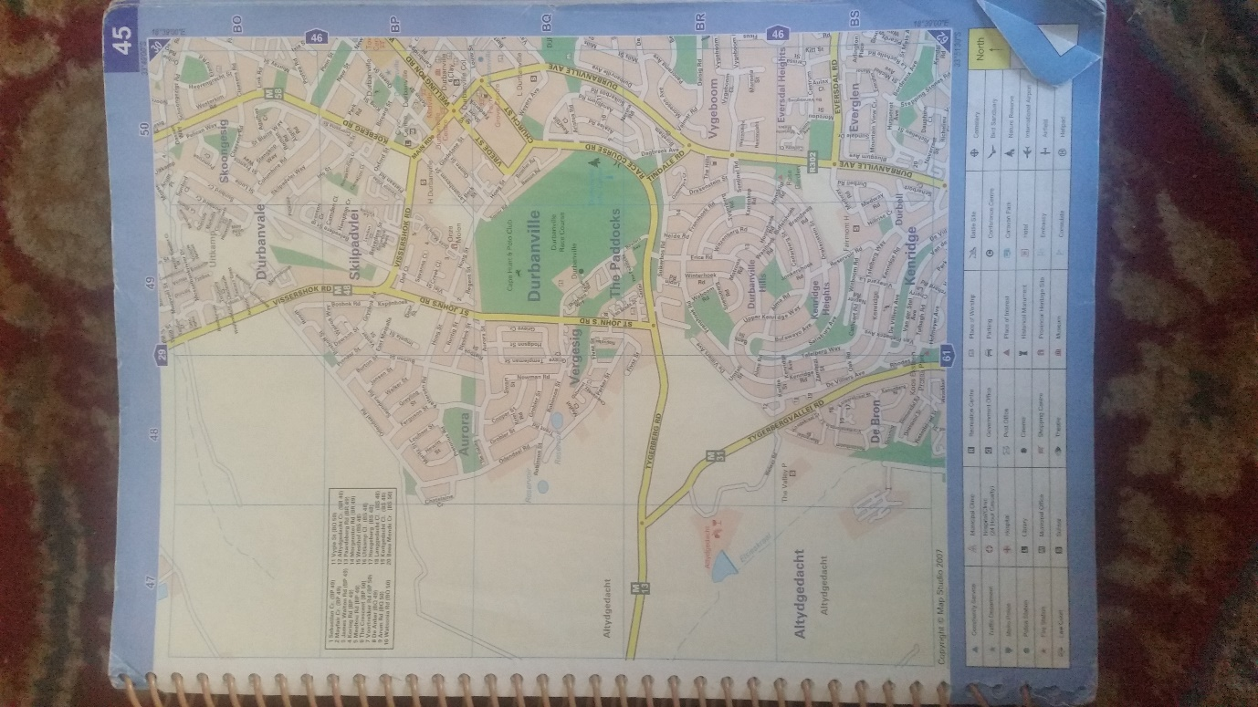
MAP 2: Nitida Wine Estate.

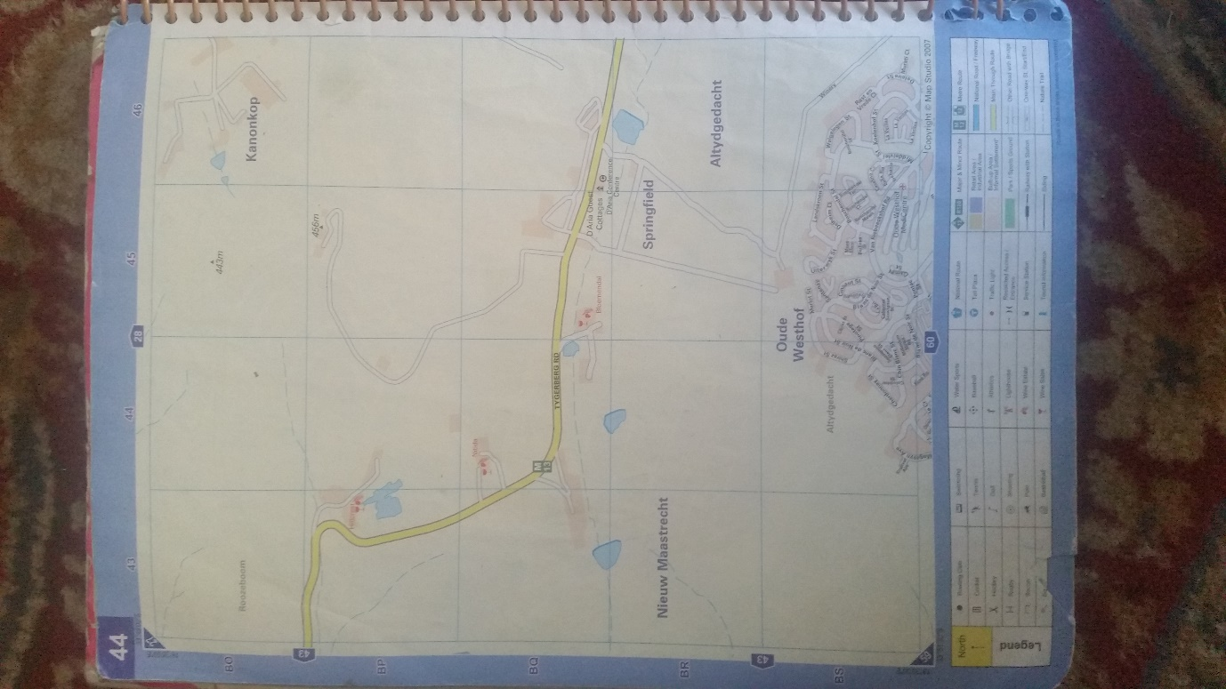
MAP 3: Nitida Wine Estate.

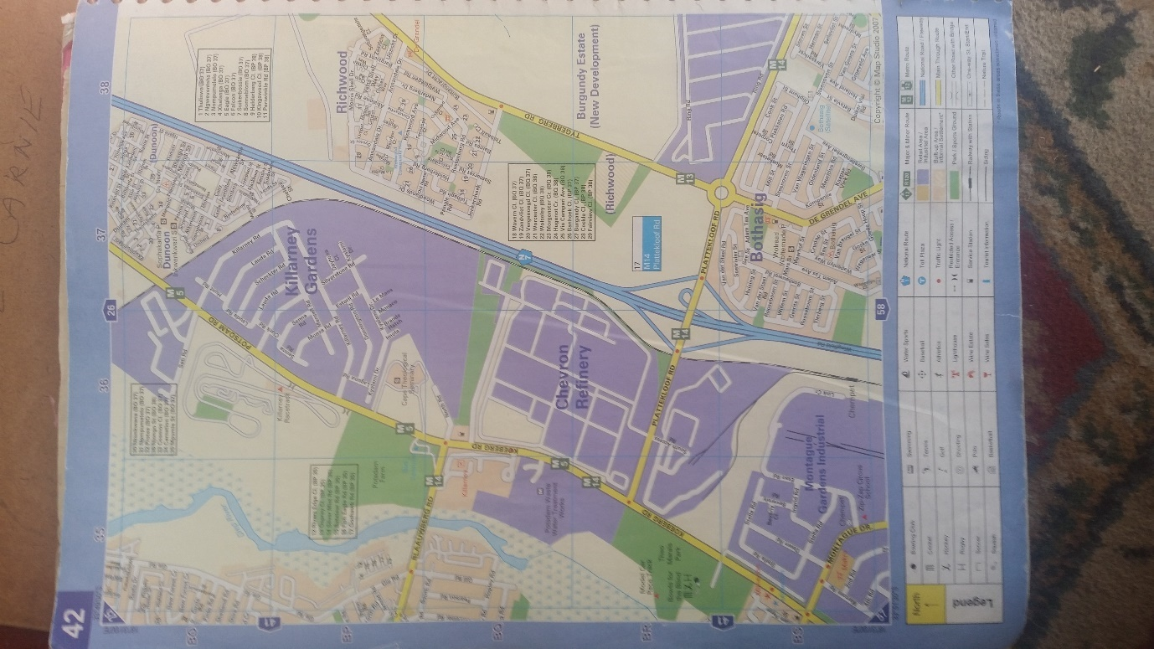
MAP 4: Nitida Wine Estate.

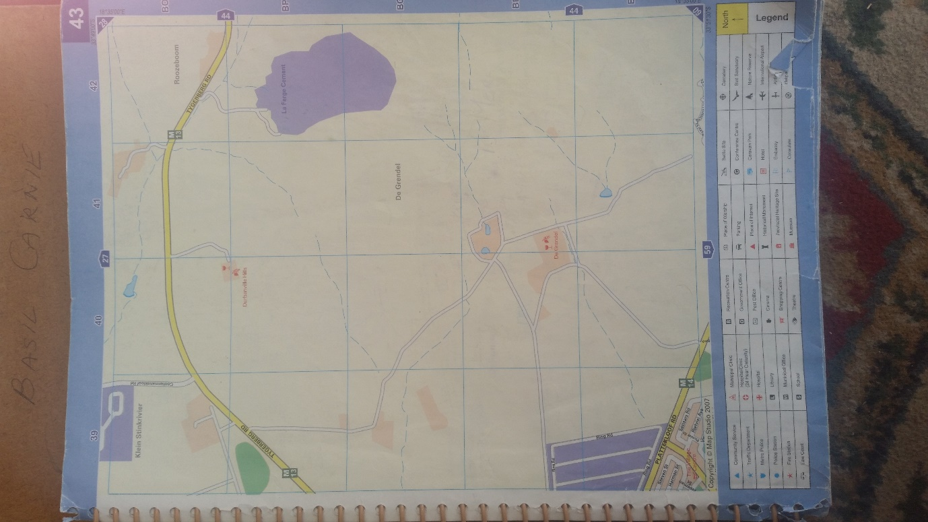
MAP 5: Nitida Wine Estate.

