Ankle Strain or Sprain
Strains and sprains (say that 10 times fast) are usually the most common reason your ankles hurt when running. An ankle strain happens when a muscle or tendon is overstretched, whereas an ankle sprain is the same injury that affects a ligament. While many other typical reasons for ankle pain stem from overuse, ankle sprains and strains are often caused by a single traumatic injury.
It doesn’t matter if you’re on smooth pavement or an uneven trail—one little misstep or incorrect landing can cause you to painfully roll your ankle. Even if you’re able to get right back on your feet, tiny micro-tears in your muscles and ligaments could add up over time to create a monster injury.
Pro tip: take care of it now—yes, that’s an order!
Strains and sprains might be the most frequent reason your ankles hurt when running, but they’re also the most treatable. As with most injuries, the painful symptoms of rolling your ankle will be easier to treat the quicker the injury is attended to. If you take care of your body at the first sign of pain, you’ll be back on your feet in no time.

2. Ankle Stress Fracture
Just like “Voldemort” in the world of Harry Potter, there’s a phrase for athletes that’s so terrifying only a few dare to say it out loud: stress fracture. Gasp! This painful injury is the bane of a runner’s existence, and it forms when your muscles can no longer absorb the shock of repetitive impact. Instead, tiny cracks form in your bone(s) which eventually crack under the stress. Yeah, not fun.
These injuries can often go undiagnosed and mask as shin splints. When left untreated, they have the potential to completely derail your daily runs and put you in a cast for several weeks. If you’re experiencing intense bruising, tenderness, or can’t run without a sharp pain in your ankle, you should see a doctor to get some X-rays. This running injury takes about six weeks to heel, so the sooner you’re seen, the better.

3. Ankle Tendonitis
Here’s a titbit of medical trivia: Tendinitis means inflammation of a tendon that forces it to fray, tear, or swell. There are several different types of tendinitis in your foot region that might be causing your ankles to hurt while you run.
- Tibialis anterior tendinitis: This tendon runs down the front of your shin bone (the tibia) and inserts at the front of your ankle. If this is where you feel ankle pain from running, it’s probably due to repetitive, forceful flexion of the foot. Trouble with your tibialis anterior tendon may also cause those dreaded shin splints (time for an ice bath!)
- Achilles tendinitis: Your Achilles tendon connects the calf muscles to the back of the heel bone (called the calcaneus). If your ankle pain from running is felt on the back of your foot above the heel, it could mean your Achilles is inflamed. Don’t suffer the same fate as the infamous Greek warrior—your Achilles tendinitis doesn’t have to be your downfall!
- Posterior tibial tendinitis: This tendon connects the posterior tibial muscle at the back of your shin to the inside of your foot. When irritated, you might feel swelling, warmth, or redness along the inside of your ankle that worsens after
- Peroneal tendinitis: If your outer ankle hurts when running, it could be caused by a swollen peroneal tendon, which connects your lower leg bone (the fibula) to that bony lump on the outside of your ankle (the lateral malleolus).
No matter which form of ankle tendinitis you’re struggling with, they all have similar causes: excessive use, ramping up your mileage too quickly, improper running form, bad footwear, low arches, flat feet, and tight calf muscles.
With ankle tendonitis, you’ll typically feel symptoms first thing in the morning or experience sharp pain while cooling down from a run. Long story short: it’s going to suck.

4. Ankle Arthritis
While you might associate arthritis with older athletes, this chronic form of pain can affect runners at any age. There are three different types of foot arthritis that can cause your ankles to hurt when running: osteoarthritis, rheumatoid arthritis, and posttraumatic arthritis. In each case, the joint is damaged or weakened, leading to stiffness and a lack of mobility.
Arthritis isn’t exclusively reserved for hardcore pavement pounders, and it doesn’t turn a blind eye toward experienced athletes either. If you notice symptoms, keep track of whether they get progressively worse so you can try to intervene before it’s too late. Sound scary? It should! Taking care of your body is no laughing matter!

5. Ankle Instability and Biomechanics
In some cases, your ankles might just be weak—plain and simple as that. Ankle instability causes your body’s natural biomechanics to “give out” whenever weight is placed on it, causing chronic pain and frequent injury while running.
Weak and wobbly ankles could be the result of overpronation, which weakens the supporting ligaments in your foot with excessive motion. When you overpronate, the placement of each step is slightly off-balance, causing your foot to roll inward and the shock of impact to be unevenly absorbed.
BAM! The Ankle Pain strikes again. This type of injury can spread upward and outward through your feet and legs, causing chronic pain that can be debilitating if left untreated. Do yourself a favour consider investing in some stability running shoes which just might become your miracle life-savers. Motion control shoes might be a good option to keep those wobbly ankles in check, but it’s always best to have your shoes fitted by a professional to ensure you’re equipped with the proper footwear for your foot type, injury, and activity.

How can I relieve ankle pain?
Alright, here’s the section we know you’ve all been waiting for. Drumroll, please!
If you’re suffering from sore ankles or frequent foot pain when running, your discomfort might be curable, if not at least preventable and treatable. Take a look at the best ways to get your running game back into tip-top shape.
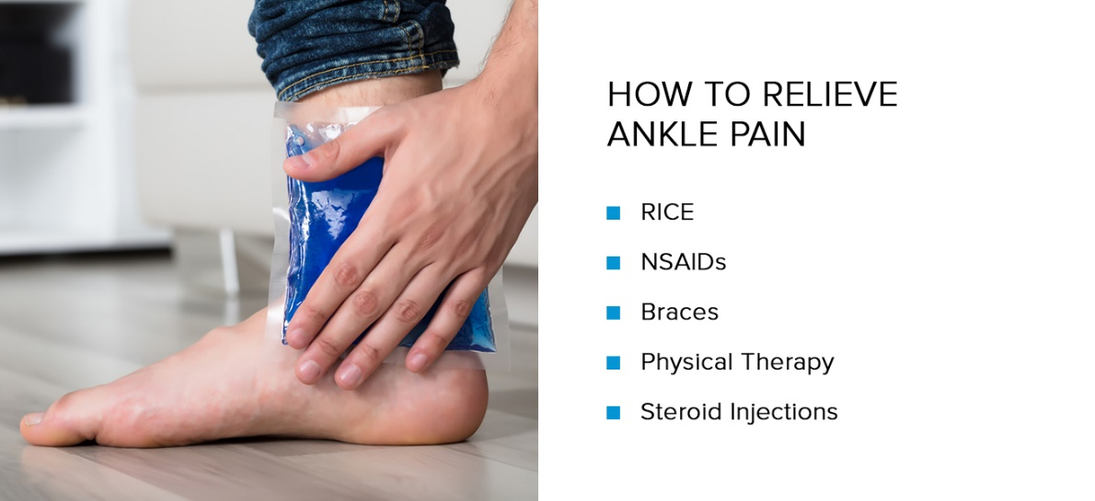
RICE: All athletes know (or should know) about the tried and true Rest, Ice, Compression, Elevation, (RICE) recovery strategy. This technique is especially effective at treating running pain from sprained ankles. Rest the joint and put as little weight on it as possible; apply an ice pack for 15-20 minutes; compress the ankle to minimize swelling and inflammation; and then elevate your injured ankle above your heart to optimize blood flow.
NSAIDs: Over-the-counter nonsteroidal anti-inflammatory drugs (NSAIDs) are great for providing relief for ankle pain caused by running. You don’t want to get in a habit of taking these regularly, though. Take them as prescribed as soon as possible following your injury for 24-48 hours to make them the most effective.
Braces: Wearing a brace, supportive wrap, or protective boot can relieve chronic ankle instability and painful stress fractures by limiting your foot’s range of motion. It might not be the most stylish accessory, but boy will it make a difference! We’re sure the fashion police will understand your decision.
Physical therapy: Exercises such as ankle circles, calf raises, and resistant band work can strengthen the muscles around your feet and help prevent sore ankles from running. But if your ankle is in a lot of pain, hold off on stretching and strengthening for 48-72 hours. Be sure to apply a heat pack beforehand to warm up those sore muscles and tendons.
- Steroid injections: No, we’re not talking about body building steroids—you won’t get disqualified from your Olympic aspirations for using these. However, you will need to seek out a medical professional to receive a steroid injection to target ankle pain. These strong, anti-inflammatory medicines are a little controversial because it can lead to the development of scar tissue. However, when used as a one-time treatment method, it can be incredibly effective at targeting tendonitis and arthritis ankle pain.
We know, ankle pain absolutely blows. But at least now you know how to identify it, treat it, and prevent it! At some point in your running career a sprain or stress fracture will slow you down, but with proper care and a determined mind, you can get through anything. Alright, enough of the cheesy pep talk. Let’s focus on kicking ankle pain to the curb!

