CURRICULUM VITAE: CARLA MOLINARO
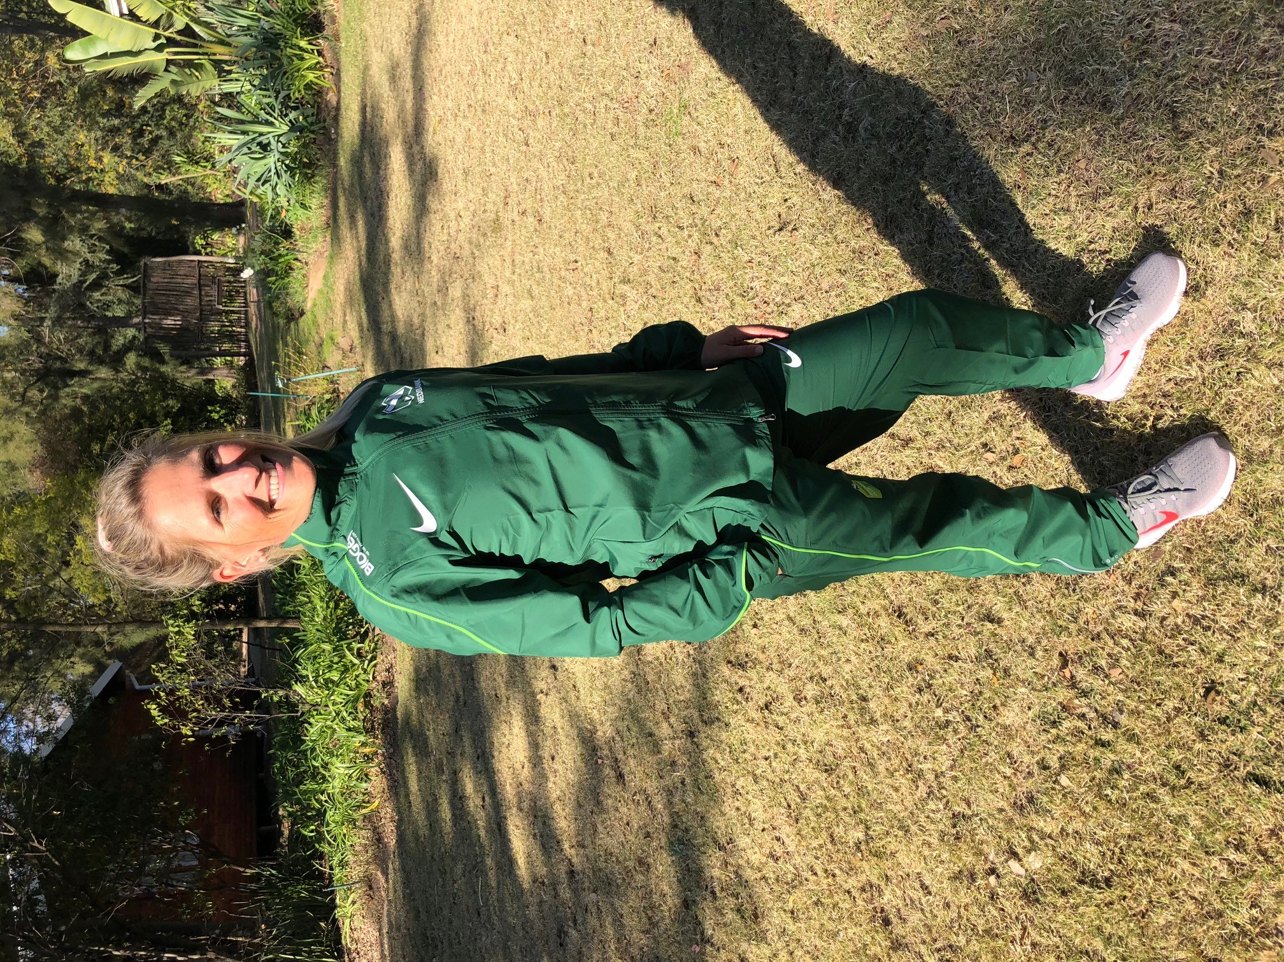

PERSONAL INFORMATION
SURNAME: Molinaro
FIRST NAMES: Carla
COUNTRY: R.S.A
DATE OF BIRTH:
CLUB: Nedbank Running Club

Personal Bests:

Distance | Time
800m | 2:20
1500m | 4:50
3000m | 10:08
5km | 18:14
5 miles | 30:44
10km | 37:08
10 Miles | 61:14
Half Marathon | 80:39
Marathon | 2:51:46
90km | 6:50:31

Running Performances:2018
Event | Distance | Time | Place
Comrades | 90.18km | 6:50:31 | 9th
Brighton Marathon | 42km | 3:01:56 | 9th

2017
Amsterdam Marathon | 42km | 2:55:57 | 19th
Brighton Marathon | 42km | 2:56:22 | 4th
Comrades | 86.7km | 7:55:05 | 27th
South Of England Fell Race | Various | Various | 1st
Wimbledon Trail Series | 12km | 53:10 | 1st
Green Belt Relay | 12km | 50:22 | 1st

2016
London Marathon | 42km | 2:57:52 | 56th
Snowdon Trail Marathon | 42km | 3:16:28 | 5th
Comrades | 89.13km | 7:23:06 | 23rd

2015
North Downs Way Trail Marathon | 42km | 3:49:56 | 1st
Chester Marathon | 42km | 2:51:49 | 2nd
Dorking 10 mIler | 10M | 64:05 | 4th

2014
Nigel Barge 10km | 10km | 37:59 | 1st
Brian Goodwin 10km | 10km | 38:15 | 1st
Kirkintilloch 12.5km | 12.5km | 49:44 | 1st
Girvin Half Marathon | 21km | 84:22 | 1st
London Marathon | 42km | 2:51:46 | 22nd

