CURRICULUM VITAE: David Manja

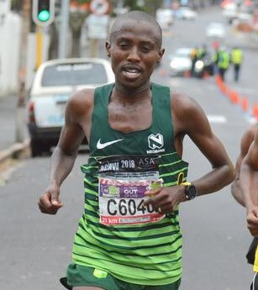

PERSONAL INFORMATION
FIRST NAMES / SURNAME: David Manja
COUNTRY: R.S. A
DATE OF BIRTH: 1991/06/08
CLUB: Nedbank Running Club
EMAIL / CONTACT / TWITTER: davidmanja1991@gmail.com / 078 305 7895 / @DavidManja1

Personal Bests
Event Result Venue Date
10,000 Metres 29:01.0 Durban (RSA) 2017
10 Kilometres 28:23:00 Casablanca (MAR) 2016
12 Kilometres 34:10:00 Cape Town (RSA) 2017
Half Marathon 1:02:15 Port Elizabeth (RSA) 2016
Marathon 2:13:33 Dublin (IRL) 2018

PERSONAL PERFORMANCES 2019
5000m Potchefstroom 14:47.65, 1st
Freedom Run 10km Port Elizabeth 29:09, 2nd
Two Oceans Half Marathon, Cape Town 1:03:40, 4th
Nelson Mandela Bay Half Marathon, Port Elizabeth, 1:08:27

PERSONAL PERFORMANCES 2018
Event Results Venue Date
10 Kilometres 28:41 Port Elizabeth (RSA) 07-Apr-18
12 Kilometres 35:26 Cape Town (RSA) 20-May-18
Half Marathon 1:03:01 Port Elizabeth (RSA) 28-Jul-18
Marathon 2:13:33 Dublin (IRL) 28-Oct-18

PERSONAL PERFORMANCES 2017
Event Results Venue Date
1500m 3:56.79 Potchefstroom (RSA) 07.03.2017
3000m 8:10.64 Potchefstroom (RSA) 15.03.2017
5000m 14:05.58 Potchefstroom (RSA) 14.02.2017
10.000m 29:01.01 Durban (RSA) 28.02.2017
10 km 29:24 Mbombela (RSA) 04.11.2017
12 km 34:10 Cape Town (RSA) 21.05.2017
Half Marathon 1:04:36 Cape Town (RSA) 08.10.2017

PERSONAL PERFORMANCES 2015 PERSONAL PERFORMANCES 2016
2nd Dischem 21km (CGA) 1:07:53 1st Outsurance Gun Run (wp) 21km 1:02:51
3rd Mafikeng (nw) 21km 1:07:45 1st Ottosdal (cnw) 21km 01:08:28
1st Ottosdal Draf En Stap (cnw) 21km 1:08:46 3rd Old Mutual Two Oceans (wp) 21km 1:03:42
4th Two Oceans 21km 1:04:15 1st Foskor (lima) 21km 1:05:08
2nd Soweto 21km 1:07:39 1st Bojanala Platinum Rustenburg (nwn) 21km 1:07:25

