CURRICULUM VITAE: DEANNE HORN

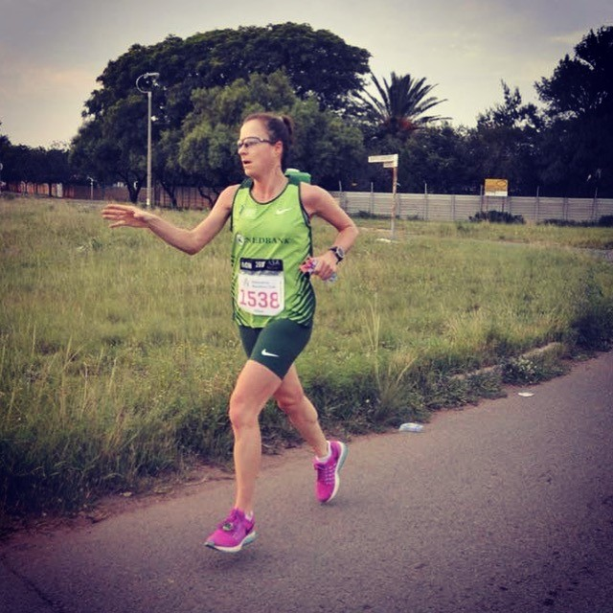

PERSONAL DETAILS
FIRST NAME / SURNAME: Deanné Horn
DATE OF BIRTH: 26 Junie 1988
CLUB: Nedbank Running Club CGA
NATIONALITY: South African
EMAIL / CONTACT / TWITTER: horndeanne@gmail.com / 082 683 4034 / @HornDeanne_

PERSONAL BEST TIMES
Distance Time Venue Year
10 km Road 38:55 Pretoria (RSA) 2018
Half Marathon 1:25:42 Knysna (RSA) 2018
Marathon 2:54:20 Border (RSA) 2019
100km ultra 8:18:00 Sveti Maurtin (Croatia) 2018

Best Performances 2019
Johnson Crane Hire Marathon 2:58:00, 3rd
Tuks Bestmed (agn) 21km 1:28:36
Sasol Sasolburg (fs) 42km 3:01:26
Comrades Marathon, 87km, 7:01:20, 12th

Best Performances 2018
Comrades Marathon 7:06, 15th
Two Oceans Ultra 4:06, 16th
100km World Championships Croatia 8:18
21.1Km Knysna 1:25, New course record, 1st
Oxpecker Trail run 32km, 2-day stage race, course record 2:39, 1st
Klerksdorp marathon 3:01, 1st

