CURRICULUM VITAE: EDWARD MOTHIBI

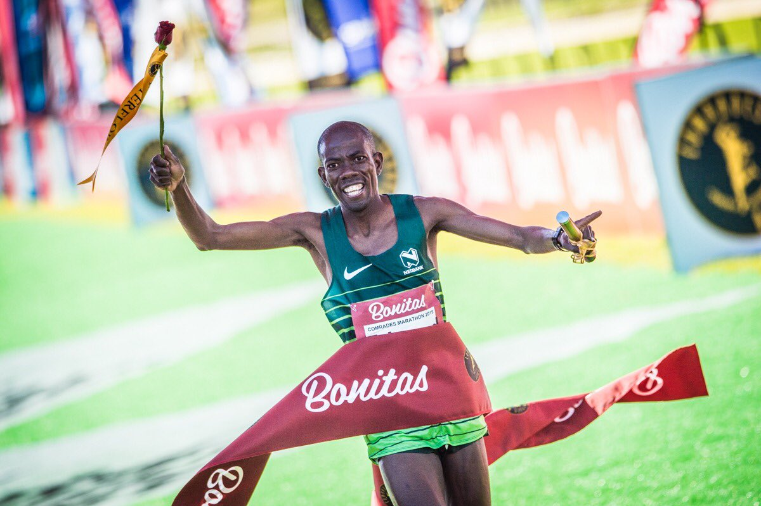

PERSONAL DETAILS
FIRST NAME / SURNAME: Edward Mothibi
DATE OF BIRTH: 10 November 1984
CLUB: Nedbank Running Club
NATIONALITY: South African
EMAIL / CONTACT: Edward.mothibi@implats.co.za / 0145690179 / 0837815475

PERSONAL BEST TIMES
Distance Time Venue Year
21km 1:04 P.E -RSA 2010
Marathon 2:24 Soweto RSA 2018
Comrades 5:31 Durban RSA 2019
Two Oceans 56km 3:22 Cape Town 2017

Best Performances 2019
Deloitte Pretoria Marathon 02:29:50, 4th
Intercare Classic 21km 01:09:31, 2nd
Om die Dam 50km, 3:05:53
Comrades Marathon, 5:31:33, 1st
IAU 50km World Champs Romania, 2:49:49, 5th

Best Performances 2018
Comrades Marathon: 5:36, 4th
FNB 10km Joburg: 30:50, 9th
Soweto Marathon: 2:24, 6th
Akasia marathon: 2:29, 1st

Best Performances 2017
Two oceans marathon: 3:22, 17th
Mandela Marathon: 2:31, 9th
Soweto Marathon: 2:25, 9th

