CURRICULUM VITAE: Eric Ngubane

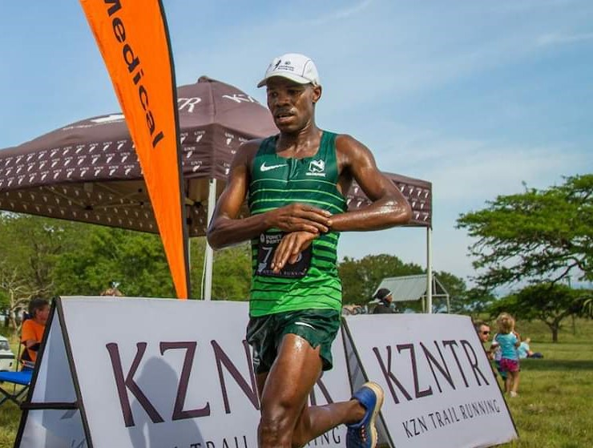

PERSONAL INFORMATION
FIRST NAMES / SURNAME: Eric Ngubane
COUNTRY: R.S.A
CLUB: Nedbank Running Club
D.O.B: 1 January 1982
NATIONALITY: South African
CONTACT / TWITTER: 073 099 3894 /

PERSONAL BEST PERFORMANCES
Distance Time Race Date
Marathon 2:27:04 Hillcrest (RSA) 2010

Personal Performances 2019
The Icon's Journey 100km 8:03:21, 2nd
Karkloof 50 Mile Endurance Foot Race (RSA) 6:58:13, 1st

Personal Performances 2018
Hibiscus Coast Challenge 48km 2:59:23, 4th
Lesotho Ultra Trail (LES) 50km 5:38:02, 1st

Personal Performances 2017
Mthatha Marathon 2:35:00
Township2Township Marathon 2:33:00

Comrades
Year Time Position
2017 Up 06:09:27 30
2016 Down 06:00:44 27
2014 Down 06:18:13 54
2013 Up 06:37:12 57
2012 Down 05:50:29 23
2011 Up 06:19:11 42
2010 Down 06:01:58 24
2009 Down 05:58:01 19
2008 Up 06:13:51 26

Trail Running
2012 Three Cranes 100km stage race, 1st
2013 Three Cranes 100km stage race, 1st
2014 Three Cranes 100km Stage race, 1st
2014 Ultra Trail Cape Town 100km, Time: 10:41:15, 1st
2015 Mount Moodie Ultra Trail 80km, Time: 9:19:43, 2nd
2015 Two Oceans Trail Run 22km, Time: 1:52:40, 2nd
2016 Two Oceans Trail Run 22km, Time: 1:53:06, 1st
2017 Golden Gate Trail Run 3-day Stage race 1st (New Record)

