FUTURELIFE® SMART BREAD™ FRENCH TOAST

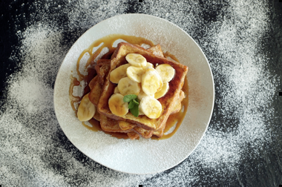
INGREDIENTS
- 3 eggs
- 125ml milk
- 4 slices FUTURELIFE® Smart Bread™
- 1ml vanilla essence
- 1 whole banana, sliced
- 60g butter or margarine
- 1ml ground cinnamon
- 15ml honey (optional)
- 5ml icing sugar (optional)

METHOD
- In a bowl, whisk together the egg, milk and vanilla.
- Place the slices of bread into a shallow dish and cover with the egg/milk mixture. Turn over after a few minutes to coat the other side of the slice.
- Heat half the butter or margarine in a frying pan, cook the bread slices on both sides until golden brown.
- Serve with the banana, cinnamon and optional honey and icing sugar dusting.

