FUTURELIFE® SMART FOOD™ CRUMPETS
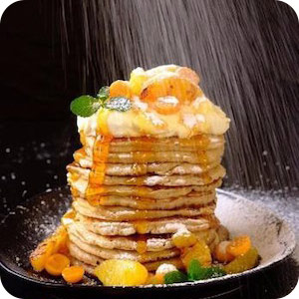
INGREDIENTS
- 150ml FUTURELIFE® Smart food™ (Chocolate or Original flavour)
- 75ml water
- 2 eggs
- Pinch of salt
- ¼ teaspoon baking powder
- 1 banana
- ¼ teaspoon oil
- Optional 1/3 cup cacao nibs

METHOD
- Blend together all ingredients except oil until smooth.
- Grease a non-stick frying pan with oil and heat to medium.
- Use a ladle to pour mixture onto the frying pan.
- When bubbles on the surface start to pop, turn the crumpet over using a spatula and cook the other side.
- Recipe makes ±5 crumpets with a diameter of 10cm.

