CURRICULUM VITAE: Fikile Mbuthuma

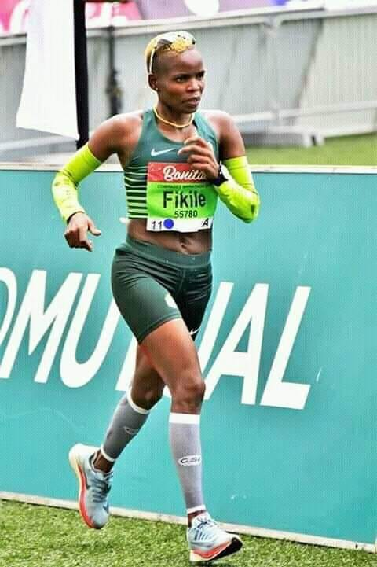

PERSONAL INFORMATION
FIRST NAMES / SURNAME: Fikile Mbuthuma
DATE OF BIRTH: 23 December 1980
CLUB: Nedbank Running Club KZN
NATIONALITY: South African
EMAIL / CONTACT / TWITTER: fikile.mbuthuma@gmail.com / 072 355 6775 / @8df05a6531bb459

Personal Bests
Event Result Venue Date
Marathon 2:58:02 East London (RSA) 2015
50km 3:55:35 Dolphin Coast Striders Ultra 2011

Comrades Marathon Results
2019 Down, 07:24:48, 29th
2018 Down, 06:54:36, 12th
2017 Up, 07:14:34, 14th
2016 Down, 06:52:32, 8th
2015 Up, 07:18:41, 15th
2014 Down, 07:08:26, 12th
2013 Up, 07:38:53, 16th
2012 Down, 07:48:14, 27th
2011 Up, 07:57:24, 34th
2010 Down, 07:44:00, 29th
2008 Up, 08:11:34, 27th
2007 Down, 08:17:37, 50th
2006 Up, 09:10:15, 171th

Best Performances 2018
Event Result Venue Date
Marathon 2:58:02 East London (RSA) 2018

Best Performances 2017
Event Result Venue Date
Marathon 3:01:44 Durban (RSA) 09.04.2017

Best Performances 2016
Event Result Venue Date
Marathon 3:08:23 East London (RSA) 20.02.2016

Best Performances 2015
Event Result Venue Date
Marathon 3:00:55 Pietermaritzburg (RSA) 22.02.2015

