CURRICULUM VITAE: GERDA STEYN

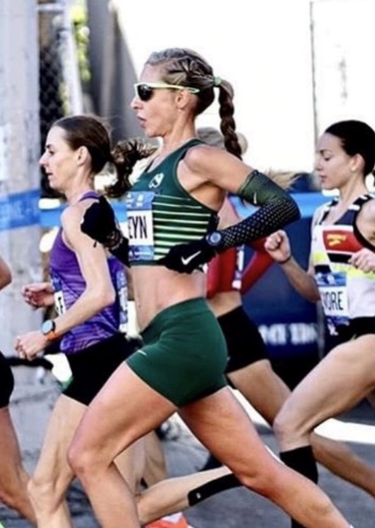

PERSONAL INFORMATION
SURNAME: Steyn
FIRST NAMES: Gerda
COUNTRY: R.S.A
DATE OF BIRTH: 1990/03/03
ID: 9003030103084
CLUB: Nedbank Running Club

PERSONAL BEST PERFORMANCES
Distance Time Race Date
5 kilometers 16:30 Durban 14 Oct 2018
10 kilometers 33:36 Durban 14 Oct 2018
Marathon 2:31:04 New York 9 Nov 2018
Two Oceans 56km 3:39:32 Cape Town 31 Mar 2018
Comrades Marathon 6:15:34 Durban 10 Jun 2018

PERSONAL PERFORMANCES 2018
Two Oceans 56km 3:39:32 1st Place
Comrades Marathon 6:15:34 2nd Place
New York Marathon 2:31:04 13th Place
SC Dubai 10km 34:30 1st Place
Middlesbrough 10km 33:58 1st Place
Spar Ladies race -Jhb 2nd Place
FNB 10km - Jhb 3rd Place

PERSONAL PERFORMANCES 2017
Comrades Marathon 6:45:45 4th Place
Valencia Marathon 2:37:22 13th Place
Great North Run 21km 1:17:26
Middlesbrough 10km 36:14 1st Place

