CURRICULUM VITAE: IRVETTE VAN ZYL

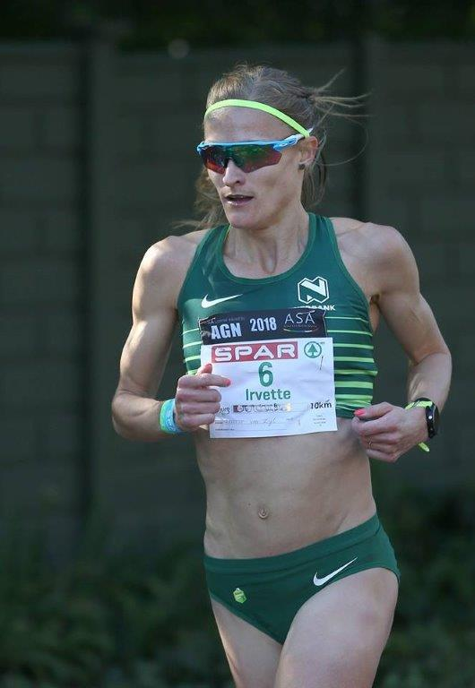

PERSONAL INFORMATION
FIRST NAMES / SURNAME: Irvette van Zyl
COUNTRY: R.S.A
DATE OF BIRTH: 1987/07/05
CLUB: Nedbank Running Club
EMAIL / CONTACT / TWITTER: irvievanblerk@gmail.com / 083 396 4208 / @irv87

PERSONAL BEST PERFORMANCES
Event Result Venue Date
1500m 04:17.5 Durban (RSA) 07.03.2003
Mile 04:48.8 Heverlee (BEL) 05.06.2004
3000m 09:11.5 Pretoria (RSA) 08.03.2016
5000m 16:02.6 Stellenbosch (RSA) 15.04.2016
10,000m 34:19.5 Durban (RSA) 17.04.2004
5 km Road 16:25 Arezzo (ITA) 27.05.2012
10 km Road 32:20:00 Stellenbosch (RSA) 09.08.2014
12 km Road 39:40:00 Cape Town (RSA) 15.05.2016
15 km Road 51:06:00 Nijmegen (NED) 17.11.2002
20 km Road 1:11:23 East London (RSA) 02.07.2006
Half Marathon 1:11:00 Port Elizabeth (RSA) 30.07.2016
Half Marathon 1:10:56 New York (USA) 20.03.2011
Marathon 2:31:26 London (GBR) 21.04.2013

PERSONAL BEST PERFORMANCES 2018
Event Position Time
Soweto Marathon 1 02:33:43
Pretoria 10 km 2 35:02
Bellville Spar Grand Prix Series 3 35:07
Pretoria Spar Grand Prix Series 4 34:56
Pietermaritzburg Spar Grand Prix Series 1 34:26
Cape Town 10 km 1 32:48
Johannesburg 10 km 1 33:52
Johannesburg SPAR Grand Prix Series 1 34:07
Durban 10 km 3 32:06

PERSONAL BEST PERFORMANCES 2017
Event Result Venue Date
5000m 16:20.06 Durban (RSA) 28.02.2017
1500m 4:23.23 Potchefstroom (RSA) 22.04.2017
10 km Road 33:07 Cape Town (RSA) 02.04.2017
Half Marathon 1:12:36 Barcelona (ESP) 12.02.2017
Marathon 2:36:46 Cape Town (RSA) 17.09.2017

PERSONAL PERFORMANCES 2016
Event Result Venue Date
3000m 09:11.5 Pretoria (RSA) 08.03.2016
5000m 16:02.6 Stellenbosch (RSA) 15.04.2016
10 km Road 33:02:00 Durban (RSA) 17.07.2016
12 km Road 39:40:00 Cape Town (RSA) 15.05.2016
Half Marathon 1:11:00 Port Elizabeth (RSA) 30.07.2016
Marathon 2:32:20 London (GBR) 24.04.2016

PERSONAL PERFORMANCES 2007 PERSONAL PERFORMANCES 2008
Dischem 21km, Johannesburg, 1st, time: 76:58 Spar Ladies 10km, Pretoria, 1st, time: 35:47
Old Mutual Freedom 15km, Johannesburg, 1st, time: 56:49 City-to-City 21km, Johannesburg, 2nd, time: 78:48
Benoni Harriers 10km, 2nd, time: 37:04 Total Sport Ladies 10km, 1st, time: 36:49
Spar Ladies 10km, Eastern Cape, 4th, time: 35:15 Spar Ladies 10km, Western Cape, 4th, time: 34:42
Nedbank JHB City 10km, 8th, time: 38:34 Breakthru 15km, Midrand, 3rd, time: 62:27

PERSONAL PERFORMANCES 2009 PERSONAL PERFORMANCES 2010
Nedbank Durban 10km, 1st, time: 34:08 George Claassen 10km, 1st time: 36:42
Akasia 21km, 1st, time: 1:21:59 Yellow Pages Series Meeting #1, 5000m, 3rd, time: 16:26:13
Spar Ladies (EP) 10km, 3rd, time: 34:39 Yellow Pages Series Meeting #3, 3000m, 3rd, time: 9:29:33
Spar Ladies Durban 10km, 7th, time: 35:25 Akasia 10km, 2nd, time: 34:55
Nedbank SA Champs 10km (Bol), 9th, time: 34:34 Two Oceans 21km, 2nd, time: 1:12:55
Nedbank Limpopo 21km, 7th, time: 1:19:45 Spar Ladies (WP) 10km, 8th, time: 35:46
City2City 21km, time: 1:22:07 Spar Ladies (EP) 10km, 2nd, time: 34:07
Spar Ladies (CGA) 10km, 3rd, time: 36:03 RAC Ladies 10km, 1st, time: 35:44
SA Champs (EP) 21km, 1st, time: 1:11:09
SA Champs (Paarl) 10km, 1st, time: 33:15
Spar Womens Race (agn), 1st, time: 34:26
Spar Womens Race (KZN), 1st, time: 33:45
Southern Region 21km Champs, 1st, time: 1:16:54
City2City 10km, 1st, time: 34:28
Spar Ladies 10km (CGA), 1st, time: 34:23
RAC Tough One 32 km (CGA), 1st, time: 2:04:54

PERSONAL PERFORMANCES 2011 PERSONAL PERFORMANCES 2012
Dischem 21km (CGA), 1st, time: 1:16:28 McCarthy Toyota 21km, 1st, time: 1:19:36
George Claassen (agn) 10km 1st, 34:34 SA 10k Champs (FS), 1st, time: 33:21
Johnson Crane (agn) 21km 01:17:25 Bestmed Tuks (agn) 10km, time: 35:12
Mccarthy Toyota (agn) 21km 1st, 01:17:24 Old Mutual Provisional Two Oceans (wp) 21km, 3rd, time: 01:16:22
Bestmed Tuks (agn) 21km 2nd, 01:15:04 Spar Womens Challenge (wp) 10km, 3rd, time: 33:32
Sunrise Monster 32km (agn) 1st, 02:12 Spar Ladies (ep) 10km, 3rd, time: 34:15
New York Half Marathon 9th, 1:10:56 Kwai Challenge (cga) 21km, 2nd, time: 01:19:17
Two Oceans 21km, 2nd, time: 1:12:04 London Marathon, time: 2:33:41
Spar Ladies PE, 2nd, time: 33:38 Spar Ladies Johannesburg, 1st, time: 34:34
SA 10km Girmiston, 1st, time: 34:03 1 Rac City Lodge Tough One (cga) 32km 02:04:44
New York Mini 10km, time: 33:56
Spar Ladies Durban, 1st, time: 32:50
Vodacom 21km, 1st, time: 1:20:35
Spar Ladies Pretoria, 1st, time: 34:55
Spar Ladies Johannesburg, 1st, time: 34:22

PERSONAL PERFORMANCES 2013 PERSONAL PERFORMANCES 2014
1 Kudus (cga) 15km 00:54:39 10 Spar Ladies (ep) 10km, Time: 34:55
1 Pwc George Claassen (agn) 10km 00:34:55 Northgate 10km, Time: 34:38
1 Mccarthy Toyota (agn) 21km 1:14:55 1 Totalsports Ladies Race 10 km 32:20
1 Totalsports Ladies (bol) 10km 32:20 1 Spar Women’s (agn) 10km 33:32
1 Northgate (cga) 10km 34:38 1 Mandela Marathon 42km 2:47:15
1 Bronkhorstspruit (agn) 32km 02:08:59 7 Bupa Great Birmingham 21km Run 1:14:24
3 Two Oceans 21km, time: 1:15:20
10 London Marathon, time: 2:31:26
3 Spar Ladies Pretoria, time: 34:21

PERSONAL PERFORMANCES 2015 PERSONAL PERFORMANCES 2016
Fnb Cape Town 12 Onerun (wp) 12km 42:18 1 Pwc George Claassen (agn) 10km 00:33:30
1 Ford 3 In 1 (agn) 21km 1:22:04 1 Akasia Wonderpark (agn) 10km 01:17:35
1 The Grove Family Day (agn) 10km 35:41 1 Deloitte Pretoria (agn) 21km 01:15:28
20 Spar Womens Challenge (wp) 10km 36:28
1 George Claassen-variable Distance (agn) 10km 36:23

