CURRICULUM VITAE: JOEL MMONE

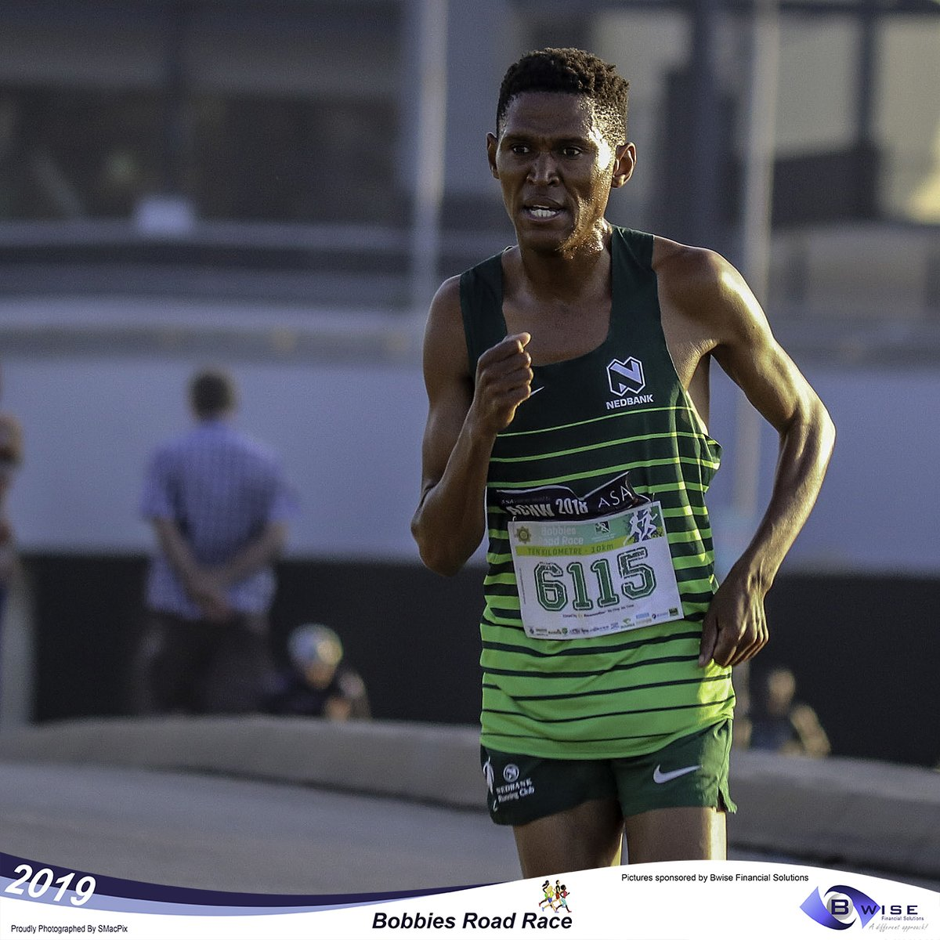

PERSONAL INFORMATION
FIRST NAMES / SURNAME: Joel Mmone
COUNTRY: R.S. A
DATE OF BIRTH: 1991/03/29
CLUB: Nedbank Running Club
CONTACT / EMAIL / TWITTER: 082 950 8746 / joelmohau@gmail.com / @joel_87050

PERSONAL BEST PERFOMNCES
DISCIPLINE PERFORMANCE PLACE DATE
10 Kilometres 28:23 Casablanca (MAR) 2016
12 Kilometres 34:35 Cape Town (RSA) 2018
Half Marathon 1:01:22 Port Elizabeth (RSA) 2019

PERSONAL PERFORMANCES 2019
Phobians (agn) 15km, 46:14, 1st
Asa 21km Champs (ep) 21km, 1:01:22, 4th
Old Mutual Two Oceans (wp) 21km, 1:05:08, 8th
Township (cga) 10km 31:52, 3rd

PERSONAL PERFORMANCES 2017 PERSONAL PERFORMANCES 2018

2 Johnson Crane (cga) 10km 29:58 1 Gaborone Half Marathon 1:03:29

3 F21 Foskor (lima) 21km 1:03:53 10 Johannesburg 10km 30:58

7 Fnb Cape Town One Run (wp) 12km 34:56 10 Cape Town 12km 34:35
9 Port Elizabeth Half Marathon 1:02:29

PERSONAL PERFORMANCES 2015 PERSONAL PERFORMANCES 2016
3 Two Oceans 21km 01:04:09 8 Sasol Sasolburg (fs) 10km 00:29:54
3 Eastern Limb Executive Mayor (lima) 21km 01:04:34 1 Ottosdal (cwn) 10km 00:31:26
2 Tembisa (cga) 10km 00:30:30 4 Two Oceans 21km 01:03:55
1 Nwn Outsurance Kfm Gun Run (wp) 21km 01:02:31 4 Foskor (lima) 21km 1:06:44
8 Fnb Cape Town 12 Onerun (wp) 12km 00:35:36 10 Nelson Mandela Bay Asa Champs (ep) 21km 1:03:16
1 Mafikeng (nw) 21km 01:07:24 9 Fnb Cape Town One Run (wp) 12km 34:58
4 Ottosdal Draf En Stap (cnw) 21km 01:12:25 8 Sasol Sasolburg (fs) 10km 29:54

PERSONAL PERFORMANCES 2013 PERSONAL PERFORMANCES 2014
1 Ottosdal Nite Race (cnw) 10km 00:31:49 3 Two Oceans 21km 01:04:29
3 Two Oceans 21km 01:03:45 1 Polokwane Mayoral (lima) 21km 1:05:39
6 Mayoral Road Race Polokwane (lima) 21km 01:04:23 1 Mtn (cga) 21km 1:04:27
1 Keystone Milling Rustenburg Mntain (nwn) 10km 00:30:56 1 Keystone Rustenburg Mountain (nwn) 10km 32:58
7 Ocean Basket Marcel Vt Slot (agn) 15km 49:10 5 Cape Town Peace (wp) 10km 29:10
6 Eastern Limb Mines (lima) 21km 1:04:14 1, Old Mutual Om Die Dam 21km, 01:06:37
1, SA Pork Kwai Challenge 10km, 00:30:30
3, Lotto Nelson Mandela Bay City Half Marathon, 01:04:25

