CURRICULUM VITAE: John April

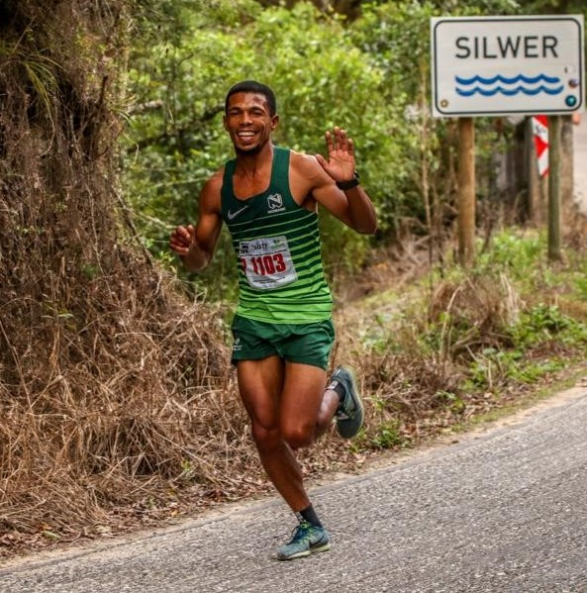

PERSONAL INFORMATION
FIRST NAMES / SURNAME: John April
COUNTRY: R.S.A
DATE OF BIRTH: 2 March 1989
CLUB: Nedbank Running Club SWD
CONTACT / EMAIL / TWITTER: 0738779329

PERSONAL BEST PERFOMNCES
DISCIPLINE PERFORMANCE PLACE DATE
56km 3:38:40 Two Oceans (RSA) 2018

PERSONAL PERFORMANCES 2019
Outeniqua (swd) 21km 1:09:57, 1st
Cango (swd) 21km 1:08:37, 4th
Beaufort West Kanniedood (swd) 21km 1:07:28, 1st
27 For Freedom (wp) 27km 1:35:29, 3rd
Bay To Bay (wp) 30km 1:46:54, 11th

PERSONAL PERFORMANCES 2018
Meiringspoort Live Life (swd) 21km 1:09:11, 3rd
Sanlam Cape Town (wp) 42km 2:28:41
Run With The Stars (swd) 10km 32:07, 2nd
Schoemanshoek (swd) 21km 1:12:45, 2nd
Old Mutual Two Oceans (wp) 56km 3:38:40

PERSONAL PERFORMANCES 2017
Sanlam Cape Town Marathon (wp) 42km 2:30:16
George Herald Run With Stars (swd) 10km 32:19, 2nd
Outeniqua (swd) 21km 1:14:40, 3rd
Old Mutual Two Oceans Ultra (wp) 56km 3:49:17
Two Lagoons (swd) 30km 1:59:11, 3rd
Cango (swd) 42km 2:29:13, 1st

