CURRICULUM VITAE: Joseph Manyedi

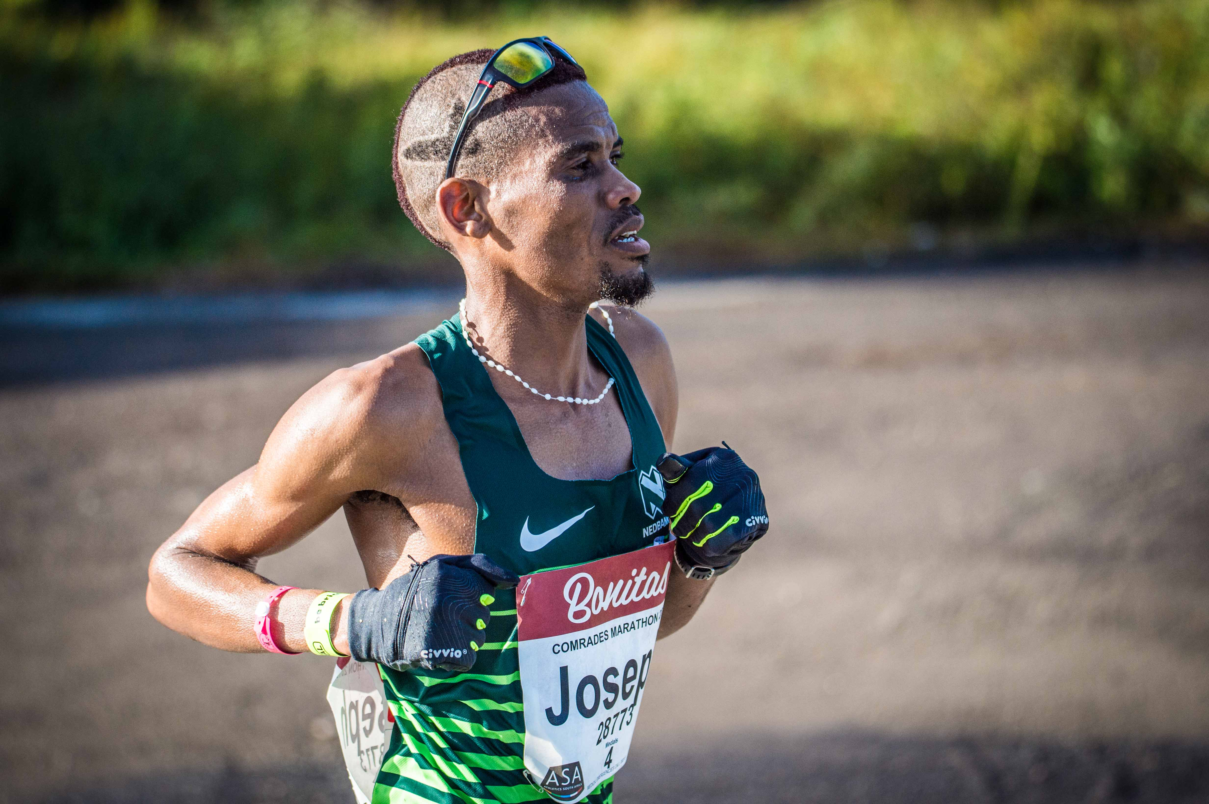

PERSONAL INFORMATION
FIRST NAMES / SURNAME: Joseph Manyedi
COUNTRY: R.S.A
DATE OF BIRTH: 24 November 1982
CLUB: Nedbank Running Club AGN
EMAIL / CONTACT / TWITTER: 079 848 3788

PERSONAL BEST PERFORMANCES
Distance Time Venue Year
Half Marathon 1:06:25 Phalaborwa (RSA) 2019
50 km 2:55:37 Om die Dam (RSA) 2019

Comrades Marathon Results
2018 Down 06:43:04
2017 Up 06:59:49
2016 Down 06:44:56
2015 Up 07:14:40
2019 Up 05:44:34

Bests Performance 2019
Om die Dam 50km 2:55:37, 1st
Tuks Bestmed (agn) 21km 1:09:23, 2nd
Johnson Crane Hire Marathon (cga) 2:23:47, 1st
Comrades Marathon Up Run, 5:44:34, 5th
Phalaborwa Foskor 21km, 1:06:25, 2nd
IAU 50km World Championship 2:51:46, 11th

