CURRICULUM VITAE: Lindikhaya Mthangayi

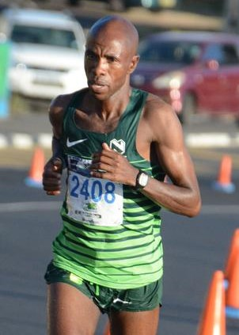

PERSONAL DETAILS
FIRST NAME / SURNAME: Lindikhaya Mthangayi
DATE OF BIRTH: 4 June 1979
CLUB: Nedbank Running Club WPA
NATIONALITY: South African
EMAIL / CONTACT: 083 743 1996

PERSONAL BEST TIMES
Distance Time Venue Year
1500 Metres 3:47.42 Bellville (RSA) 2002
5000 Metres 13:41.96 Durban (RSA) 2002
10,000 Metres 29:20.30 Stellenbosch (RSA) 2005
10 Kilometres 28:24 Stellenbosch (RSA) 2009
15 Kilometres 45:43 Cape Town (RSA) 2004
Half Marathon 1:01:32 Port Elizabeth (RSA) 2009
Marathon 2:20:46 Durban (RSA) 2009
Two Oceans 56km 3:21:30 Cape Town (RSA) 2019
Comrades 6:33:11 Pietermaritzburg (RSA) 2018

Best Performances 2019
Peninsula Marathon, Simon's Town (RSA) 2:27:01, 1st
Two Oceans 56km 3:21:30, 13th

Best Performances 2018
Cape Town Marathon 2:21:17
Two Oceans 56km 3:28:06

