CURRICULUM VITAE: Lungile Gongqa

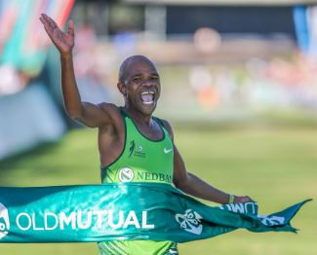

PERSONAL DETAILS
FIRST NAME / SURNAME: Lungile Gongqa
DATE OF BIRTH: 22 February 1979
CLUB: Nedbank Running Club
NATIONALITY: South African
EMAIL / CONTACT / TWITTER: ivysogiba01@gmail.com / 073 720 1255 / @lungile_gongqa

PERSONAL BEST PERFORMANCES
Distance Time Area Date
10 km Road 29:09 Mdantsane (RSA) 2013
12 km Road 35:39 Cape Town (RSA) 2015
15 km Road 45:20 Cape Town (RSA) 2013
Half Marathon 1:03:57 Port Elizabeth (RSA) 2016
Marathon 2:11:59 Cape Town (RSA) 2015
56km 3:09:38 Cape Town (RSA) 2017

Best Performances 2019
Top Form 10km, Cape Town 30:54, 1st
Nelson Mandela Bay Half Marathon, Port Elizabeth 1:05:55
Peninsula Marathon, Simon's Town 2:27:23, 2nd
56km Two Oceans (wp) 3:18:53, 8th
IAU 50km World Championships, 2:48:26, 2nd

Best Performances 2018
Marathon Cape Peninsula (wp) 02:21:58, 1st
21km Sasolburg (fs) 01:11:51, 5th
21km East London 01:06:03
56km Two Oceans (wp) 3:22:54, 19th
Cape Town Marathon 02:21:42

Best Performances 2017
10km Rondebosch (RSA) 30:46
12km Cape Town (RSA) 36:55
21km Port Elizabeth (RSA) 1:05:05
Marathon Mumbai (IND) 2:18:52
56km Two Oceans Cape Town (RSA) 3:09:38, 1st

