CURRICULUM VITAE: MTHANDAZO QHINA

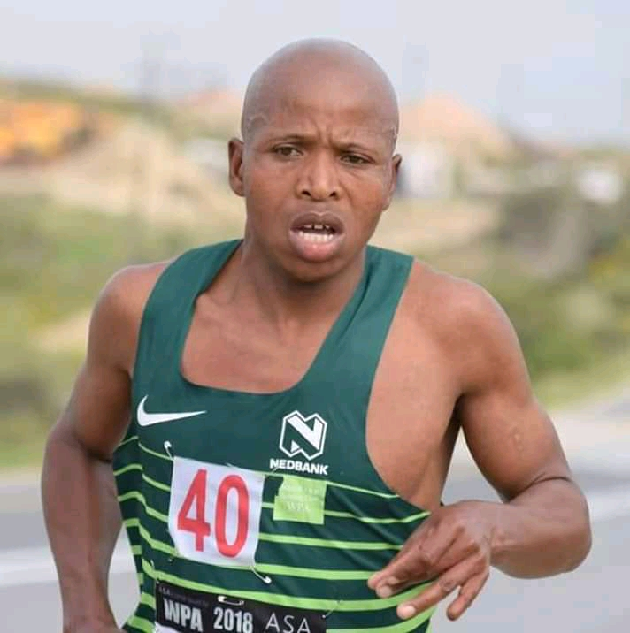

PERSONAL DETAILS
FIRST NAME / SURNAME: Mthandazo Qhina
DATE OF BIRTH: 25 September 1977
CLUB: Nedbank Running Club CT (WP)
NATIONALITY: South African
CONTACT / TWITTER: 0722978068 / @Qhinarunner
FACEBOOK: MTHANDAZO QHINA(TAYLOR)

PERSONAL BEST TIMES
Distance Time Venue Year
10 km Road 29:53 Cape Town (RSA) 2017
15 km Road 45:27 Eerstrivier (RSA) 2015
Half Marathon 1:05 Mosselbay (RSA) 2017
Marathon 2:17:11 Cape Town (RSA) 2012
Marathon 2:17:43 Cape Town (RSA) 2015
Two Oceans 56km 3:10:02 Cape Town (RSA) 2013

Best Performances 2019
Medihelp Tekkie Challenge 10km Cape Town 31:41, 3rd
Avbob Eersterivier 15km Eersterivier 47:35, 1st
Nelson Mandela Bay Half Marathon Port Elizabeth 1:07:57
Two Oceans Marathon (RSA) 56km 3:17:29, 6th
Peninsula Marathon Simon's Town 2:30:44, 3rd
Sanlam Cape Town Marathon Cape Town 2:23:57

Best Performances 2018
Nantes 10km 30:44
Hohenort 15km 48:11
SA Half Marathon Champs (PE) 1:07:00
Cape Town Marathon (SA Champs) 2:20:32

Best Performances 2017
Mosselbay Bay 21.1km 1:05
Dublin Marathon 2:25

Best Performances 2016
Cape Town Marathon 2:20

Best Performances 2015
Two Oceans 56km Ultra Marathon 4th

Other Achievements
4 Two Oceans Gold medal.
Western Province Male Road Runner of the Year (2018) (2015) (2014) (2013) (2012)

