CURRICULUM VITAE: Ntombesintu Mfunzi

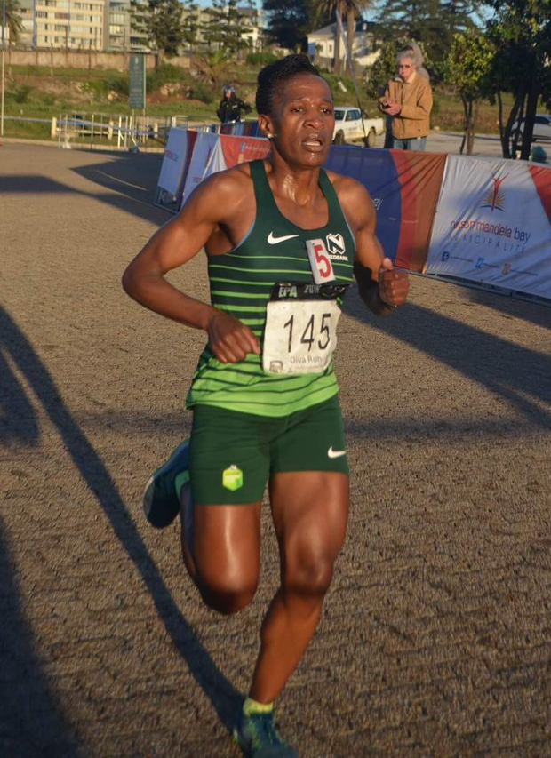

PERSONAL INFORMATION
FIRST NAMES / SURNAME: Ntombesintu Mfunzi
COUNTRY: R.S.A
DATE OF BIRTH: 1981/12/27
CLUB: Nedbank Running Club
EMAIL / CONTACT / TWITTER: ntombesintumfunzi@yahoo.co.za / 079 671 9059 / @ntombesm

Personal Bests
Event Result Venue Date
1500 Metres 4:42.5h Port Elizabeth (RSA) 26-Feb-05
3000 Metres 09:52.6 Potchefstroom (RSA) 19-Feb-11
5000 Metres 16:37.3 Port Elizabeth (RSA) 19-Feb-10
10 Kilometres 34:35:00 Stellenbosch (RSA) 29-Aug-09
12 Kilometres 43:29:00 Cape Town (RSA) 21-May-17
15 Kilometres 55:45:00 Port Elizabeth (RSA) 04-Oct-08
20 Kilometres 1:16:29 East London (RSA) 02-Jul-06
Half Marathon 1:16:30 Port Elizabeth (RSA) 02-Jul-11
30 Kilometres 2:00:50 Uitenhage (RSA) 05-Mar-16
Marathon 2:47:56 Cape Town (RSA) 23-Sep-18

Two Oceans
2018 Two Oceans Marathon 56km 3:59:27 10th
2017 Two Oceans Marathon 56km 4:01:21 5th
2015 Two Oceans Marathon 56km 4:21:05 16th
2014 Two Oceans Marathon 56km 4:00:53 8th
2012 Two Oceans Marathon 56km 3:52:38 8th

2018
15 km Road 56:57 Jeffreys Bay (RSA)
Port Elizabeth Freedom Run 10K 35:06, 3rd
Port Elizabeth Spar Grand Prix Series 34:54, 9th
Port Elizabeth 10 km 35:49, 4th
Durban Spar Grand Prix Series 35:47, 14th

2017
10 km, 35:57 Port Elizabeth (RSA)
12 km Road, 43:29 Cape Town (RSA)
15 km Road, 56:00 Port Elizabeth (RSA)
Half Marathon, 1:17:31 Port Elizabeth (RSA)
30 km Road, 1:54:43 Uitenhage (RSA)

2016
5000m 17:20.73 Stellenbosch (RSA)
10 km Road 35:28 Port Elizabeth (RSA)
15 km Road 58:14 Jeffreys Bay (RSA)
Half Marathon 1:20:00 Cape Town (RSA)
30 km Road 2:00:50 Uitenhage (RSA)

2014
Nelson Mandela Bay Freedom (wp) 10km 34:57
Correctional Services (ep) 10km 35:03
Cassies (ep) 15km 56.24
Kromberg Schubert (ep) 15km 57:30
Bluewater Bay (ep) 15km 57:40
Old Mutual Provisional Two Oceans (wp) 56km 4:00:52, 7th place
1st Wing for Life World Run (4th in the World)

2013
City2City Ultra Marathon 50km 3:40:33 4th
Canrad the Human Race (ep) 10km 34:25
Freedom Run (ep) 10km 35:52
Cassies (ep) 15km 54:13

2012
Petro Sa (swd) 21km 1:18:39
Clover (ep) 10km 35:21
Volkswagen (ep) 10km 35:00
Motherwell Freedom Run (ep) 10km 34:47
Old Mutual Provisional Two Oceans (wp) 56km 3:52:39, 8th place
Umhlobo Wenene (ep) 10km 35:08
Lemaitre (ep) 10km 35:55
Woodlands (ep) 15km 56:50

2011
Petro SA (swd) 42km 2:49:38
Clover Milk Run (ep) 10km 35:02
SA (ep) 21km 1:16:30
Spar (ep) 10km 35:11
Umhlobo Wenene Classic Fm (ep) 10km 34:49
Spar Womens (wp) 10km 35:08
Cassies (ep) 15km 55:56

