CURRICULUM VITAE: Phillimon Mathiba

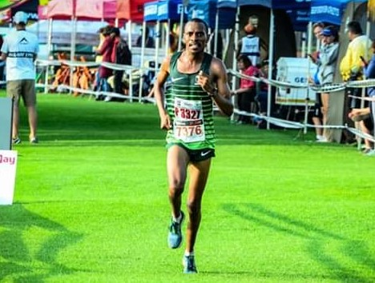

PERSONAL DETAILS
FIRST NAME / SURNAME: Phillimon Mathiba
DATE OF BIRTH: 2 May 1992
CLUB: Nedbank Running Club CGA
NATIONALITY: South African
EMAIL / CONTACT / TWITTER: phillimonmathiba@gmail.com / 062 630 0922 / @Phillim90319981

PERSONAL BEST TIMES
Event Result Venue Date
10 km Road 30:15 Sasolburg (RSA) 2016
Half Marathon 1:02:40 Port Elizabeth (RSA) 2016
Marathon 2:18:24 Dublin (IRL) 2017

PERSONAL PERFORMANCES 2019
5000m Germiston 14:47.74, 5th
Two Oceans Half Marathon, Cape Town 1:07:39
Nelson Mandela Bay Half Marathon, Port Elizabeth 1:05:08

PERSONAL PERFORMANCES 2018
1500m Germiston 1st, 3:55.99
5000m Germiston Central Gauteng Ch. 4th, 14:57.96
5000m Pretoria South African Ch. 18th, 15:10.16
10,000m Germiston 5th, 9:50.7h

PERSONAL PERFORMANCES 2017

Durban 10,000m, 29:33.50

Bedfordview Half Marathon 1:08:56

Potchefstroom (RSA) 5000m 14:31.42

Cape Town (RSA) 12 km Road 36:14

ASA 21km Championships (ep) 1:04:36
Dublin Marathon (Irland) 2:18:24 (8th)

PERSONAL PERFORMANCES 2016
4th Johnson Crane (cga) 10km, 30:07
3rd Outsurance Gun Run (wp) 21km, 1:06:18
3rd Foskor (lima) 21km, 1:05:39
9th Nelson Mandela Bay Asa Champs (ep) 21km, 1:02:40
2nd Northgate (cga) 10km, 31:56
3rd Miway Wally Hayward (agn) 10km, 32:09
4th Mayoral Race Polokwane (lima) 10km, 33:09
3rd Old Mutual Om Die Dam (nwn) 10km, 30:24
3rd Spar Irene Lantern (agn) 10km, 30:59

PERSONAL PERFORMANCES 2015
1st Rainbow Komatsu (cga) 10km, 31:18
3rd Run 4 Education (lima) 10km, 31:11
2nd Northgate (cga) 10km, 31:24
1st Slowmag (cga) 21km, 1:06:15
3rd Gert Sibande Municipality (mpu) 21km, 1:09:10
2nd Spar Irene Lantern Night (agn) 10km, 30:25
3rd Johnson Crane (cga) 10km, 29:12
3rd Dis-chem 5km Dash (cga) 5km, 15:23

