SETTING SMART GOALS AND USING SMART NUTRITION TO ACHIEVE THEM
BY: Sonal Ratan / DATE: November 2018
DATE OF NEXT REVIEW: November 2021

Your annual leave has ended, you’re back at work and there are no more Christmas movies showing on TV- 2018 has officially ended. As you open your diary to the first crisp page of 2019, you begin to think about year ahead and the resolutions you plan to make. Before you begin, here are a few tips to ensure that your resolutions and ways to achieve them are SMART.

SETTING SMART RESOLUTIONS
SMART refers to setting goals that are:
S- Specific: What would you like to achieve? Be specific about your goal and how you plan on achieving it. E.g. If you want to lose weight and lead a healthy lifestyle how do you plan on doing this? What are the bad habits that you need to change in order to achieve your goal?

M- Measurable: This helps to refine exactly what you want to see when you have reached your goal. E.g. How much weight do you want to lose, what clothes size do you want to be, how many times per week do you plan on doing cardio, going to gym or exercise classes, how many servings of fruits and vegetables do you plan on eating per day?

A- Attainable: Make sure that your goal is attainable. Will you have enough time to complete it and have you budgeted for the costs involved? Is it achievable considering the obligations and priorities you have? E.g. If you can’t afford a personal trainer and you don’t have the time to train for 2 hours, plan on attending exercise classes at the gym and training for 1 hour during the week and longer when you have more time on the weekend. This doesn’t mean that you shouldn’t ‘go big’ when setting your goal as something that seems impossible can be achieved when planning ahead and being determined to achieve it, just be realistic.

R- Realistic: Set a goal that will be realistic to achieve. If you know that you’re not a morning person and struggle to wake up, don’t set a goal to wake up at 04H00 to exercise. If you’ve never done long distance running and have just started, don’t set your goal to be running long distance marathons when you know you don’t realistically have enough time to train and work yourself up to running longer distances.

T- Time bound: Set yourself goals that need to be reached throughout the year as well as at the end of the year. How much weight do you plan on losing every month and then by the end of the year? These ‘deadlines’ will help you to keep on track and achieve your end goal.

SMART NUTRITION TO ACHIEVE YOUR GOALS
FUTURELIFE® Smart food™ offers Smart food for complete nutrition to help you achieve your goal. Whether you’re a student, busy executive or a mom always on the go we’ve got you covered. Here are a few examples of how:

Losing weight or maintaining a healthy weight:
The FUTURELIFE® Smart food™ formulation is high in protein, dietary fibre, omega 3 and 13 vitamins. It is also low GI for sustained energy levels to keep you fuller for longer. Thus, the product is the perfect choice to include in a healthy, balanced diet for someone trying to lose or maintain a healthy weight. Remember that portion size is also key. One serving is equal to 50g or 5 heaped tablespoons. For a lower carbohydrate and higher protein option you can also use FUTURELIFE® HIGH PROTEIN Smart food™

Skipping meals & eating on the go:
We understand that time is precious however your health is even more precious. If you’re guilty of skipping meals then we have the solution for you. Always keep a sachet of FUTURELIFE® Smart food™ in your bag, car or at work. It takes only a couple of minutes to tear it open, pour it out into a bottle or bowl and enjoy it as a meal or shake with either milk or water. You can also rest assured that you’re not only getting convenience but also a balanced meal. One serving would be the equivalent of:
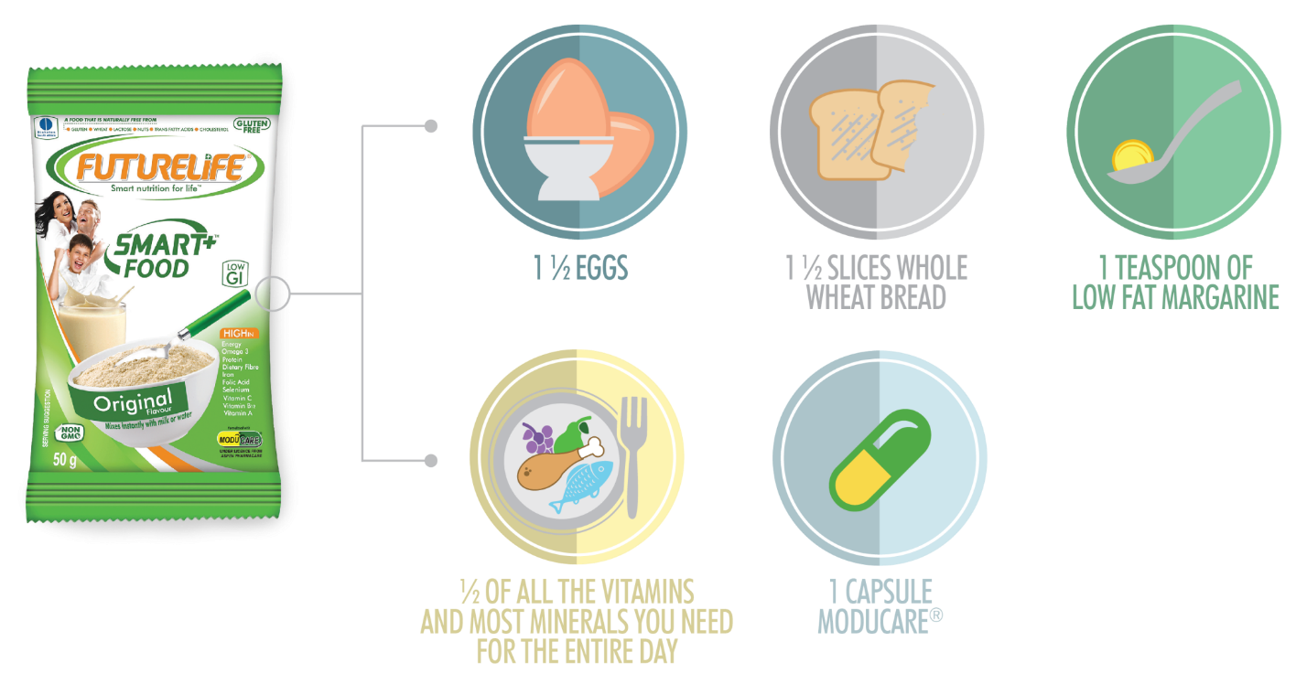

MODUCARE® is a daily immune supplement made from a patented blend of natural plant sterols and sterolins. It can be purchased from a pharmacy however we have included it in our formulation to ensure that we provide you with an ‘all-in one’ functional food. So, not only does it provide smart nutrition, but also a cost-effective option as FUTURELIFE® Smart food™ works out to be a lot more cost effective than the price of its food equivalent.

The start of a new year is the perfect motivation to get you started with healthy living. Making your resolutions a habit is what will keep you going. So, kick start 2019 off the smart way and make your health a permanent priority.

