CURRICULUM VITAE: Tanith Maxwell

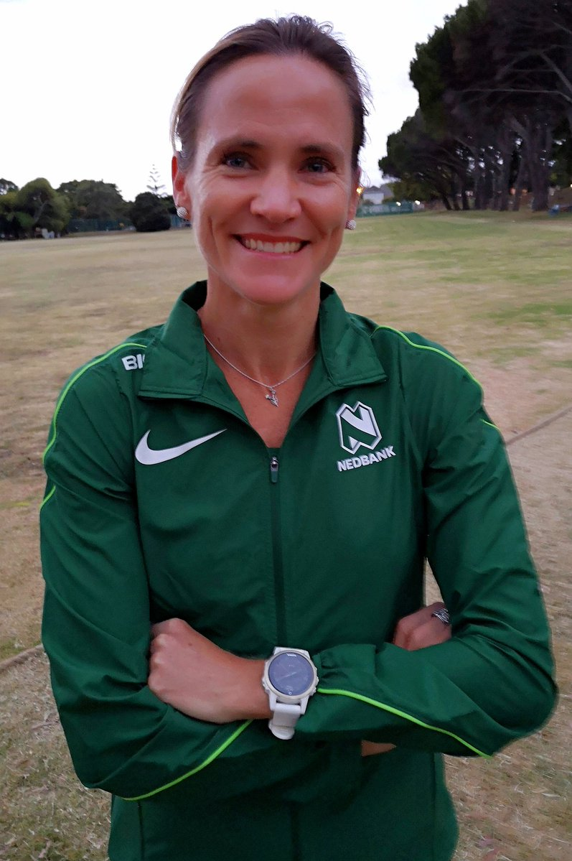

PERSONAL INFORMATION
FIRST NAMES / SURNAME: Tanith Maxwell
DATE OF BIRTH: 2 June 1976
CLUB: Nedbank Running Club
NATIONALITY: South African
EMAIL / CONTACT / TWITTER: t.foxmax@gmail.com / 081 747 8553 / @tanithmaxwell

Personal Bests
Event Result Venue Date
10 Kilometres 34:01:00 Durban (RSA) 26-Jul-09
12 Kilometres 44:46:00 Cape Town (RSA) 21-May-17
15 Kilometres 53:22:00 Cape Town (RSA) 10-Mar-12
10 Miles Road 58:58:00 Portsmouth (GBR) 25-Oct-09
20 Kilometres 1:13:25 East London (RSA) 02-Jul-06
Half Marathon 1:13:22 Port Elizabeth (RSA) 24-Jul-10
25 Kilometres 1:32:21 Berlin (GER) 05-May-13
30 Kilometres 1:56:32 Cape Town (RSA) 04-Jan-15
Marathon 2:32:33 Berlin (GER) 26-Sep-10

Comrades Marathon Results
2018 Down, 06:20:35, 4th

Two Oceans Marathon Results
2002 Half 1:22:27 8th
2003 Half 1:19:39 4th
2004 Half 1:18:06 3rd
2005 Half 1:21:01 6th
2010 Half 1:16:19 4th
2015 Ultra 3:45:19 3rd
2016 Ultra 3:45:55 2nd
2017 Ultra 3:55:37 3rd
2018 Ultra 3:49:49 4th

Best Performances 2018
Event Result Venue Date
10 Kilometres 36:15:00 Cape Town (RSA) 07-Mar-18
Marathon 2:49:49 Cape Town (RSA) 23-Sep-18

