WHY WE GLOAT ABOUT WHOLE GRAIN OATS
BY: Angela Leach / DATE: April 2019
DATE OF NEXT REVIEW: April 2021

Most of us know that oats are delicious and provide a great amount of comfort in the cold winter months, but did you know that they are one of the healthiest grains you can eat¹? Also known as Avena sativa, including oats in your diet can provide a host of health benefits. Let’s chat more about them.

OATS NATURALLY PROVIDE A VARIETY OF NUTRIENTS
Whole grain oats are extremely nutritious. Aside from being a good source of energy providing carbohydrates, they also offer lots of fibre, including soluble fibre and the exceptional oat beta-glucans, which will be highlighted further in this article. When compared to other grains, they are higher in protein and fat¹.

Oats also offer a variety of micronutrients (vitamins and minerals), providing commendable amounts of nine and smaller amounts of another 4, a total of 13 micronutrients!

Finally, over and above the nutrients mentioned, oats also provide a variety of health-promoting plant compounds and anti-oxidants. The total nutritional composition provides many of the benefits discussed below^{1,2}.

HEALTH BENEFITS OF OATS
The total nutrient profile of oats provides multiple health benefits from blood pressure control to constipation prevention. Here are some key benefits to keep you loving oats.

Cholesterol lowering
Oats are high in beta-glucans which are conclusively proven to lower both total cholesterol and the ‘bad’ LDL cholesterol, which can thereby reduce the risk of heart disease and strokes^{1,3}.

Blood sugar control
Beta-glucans also have benefits in controlling blood sugar levels. They improve insulin sensitivity and help to lower blood sugar. This benefit is conclusively proven in both overweight and type-2 diabetes populations^{1,4,5}.

Weight management
Oats are high in fibre, especially soluble fibre which attracts water and forms a gel thereby slowing down digestion and keeping you full, which helps with weight managemet^{1,6}. They also have a positive effect on the appetite-control hormones⁶.

CONCLUSION
There is no doubt that often choosing to include oats in your diet can make you a healthier person overall. They are rich in nutrients and fibre, which provides for benefits ranging from weight loss to cholesterol lowering and what’s more, they taste great!

FOR WHOLE GRAIN OATS TRY FUTURELIFE® WHOLE GRAIN GRANOLA BARS
FUTURELIFE® Whole Grain Granola Bars are SA’s 1st* certified Gluten Free Whole Grain Bars with added sterols
and sterolins. These crunchy, wholesome oat-based bars are suitable as a snack any time of the day.
Providing 20 g of whole grains per serving, this bar boasts fibre, with no gluten, artificial colours, flavours or preservatives. To learn more visit www.futurelife.co.za.
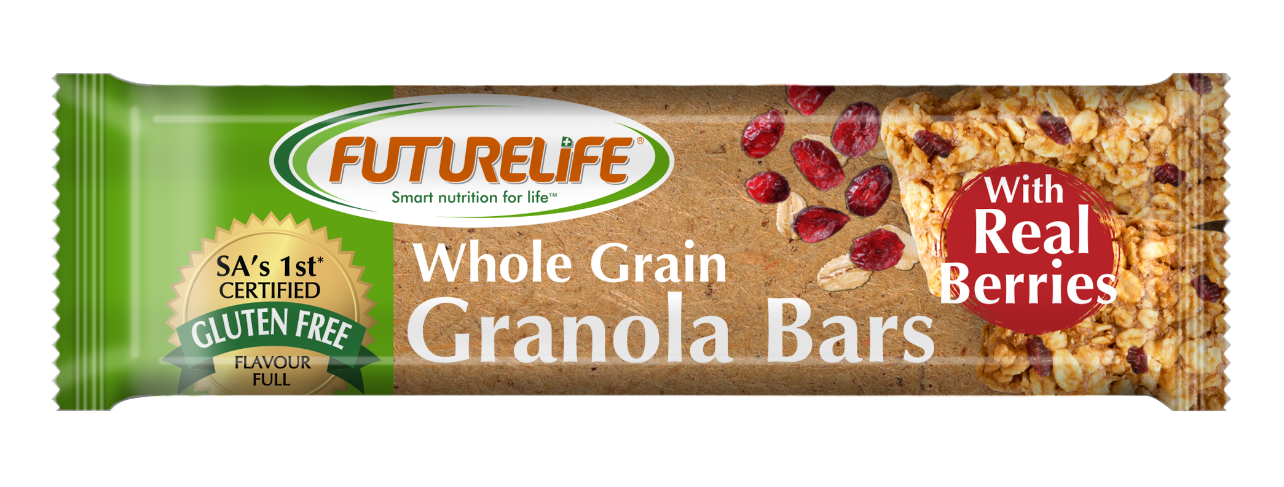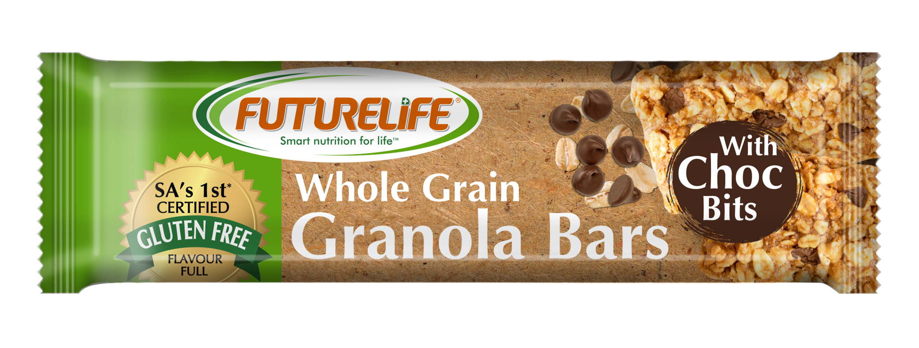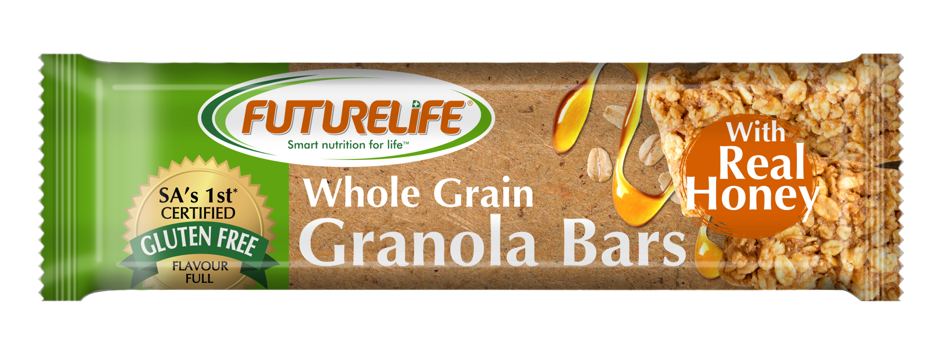

REFERENCES
- https://www.healthline.com/nutrition/9-benefits-oats-oatmeal
- http://www.whfoods.com/genpage.php?tname=foodspice&dbid=54
- https://www.ncbi.nlm.nih.gov/pubmed/25411276
- https://www.ncbi.nlm.nih.gov/pubmed/12080401
- https://www.ncbi.nlm.nih.gov/pubmed/18837470
- Nicola Wilken: the many benefits of oats.

