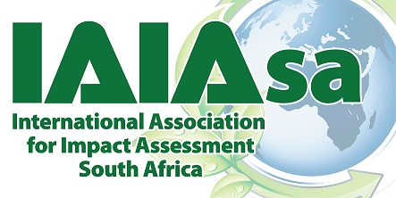
Document type: | Minutes of the IAIAsa Annual General Meeting 2017
Event: | IAIAsa Annual General Meeting held at Goudini Spa, Western Cape
Event date: | Thursday, 18 August 2017
Event time: | 11:00 – 12:13

1. | Welcome | Members were formally welcomed by meeting facilitator, Sean O’Beirne. Members were requested to complete the attendance register.
2. | a. Attendance  Total 127 present  b. Apologies  Leandri Kruger, Nozi Nkoe, John Richardson
3. | Approval of Agenda |  | The agenda, which was accepted, was circulated prior to the meeting.  Proposer: Mark Wood  Seconder: Terry Calmeyer
4. | Approval of the minutes of the previous AGM (18 August 2016) |  | No comments received.  Proposer: Mark Wood  Seconder: Terry Calmeyer
5. | Matters Arising from the minutes of the previous meeting |  | - Disciplinary code – still in preparation.  - Proxy – was included in e-brief circulated
6. | Reports on activities 2016/2017
President’s Report by Janice Tooley |  | - Membership  - Move from manual system to online database. Lots of teething problems experienced. End June 850 members. Will be adding functions to allow for member responsibility to update the system  - Event management system – working well.  - Accounting system – got right this year.  - Categories – implemented 2 new categories - 3 year and group. Very successful.  - National Executive Committee – 14 on committee. Met personally twice. Skype sessions every 6 weeks.  - Branches – 6 functioning branches. Held 26 events collectively. Student branches – 10 in past year. We’re not able to resurrect Eastern Cape or Limpopo. Reviewed branches in respect to succession and consistency which was the main reason for amendments to constitution.  - Operations – Sue George in her 2nd year. Assisted by Leeanne du Plessis.  - Finances – emphasis placed on getting systems up and running. Jenny left legacy for the organisation.  - Communications – not as often as a result of database upgrades.  - Changes to the constitution – significant need this year.  - Relationships – met with DEA. Providing a good communication conduit. Also met with other Voluntary Organisations. Also working with relevant registration authorities. Working with parastatals and other businesses.  - Funding – proSet funding of R30 000 used to reward mentor and top mentees as part of ISMP.  - Mentorship – piloted ISMP. 10 pairings. Rolled out in 2017 – 11 pairs. Request for professionals to participate.  - Transformation – call for active transformation, specific portfolio on NEC created.  - National Conference – Thanks to Mari and team.  - IAIA – IAIAsa is an affiliate to international body. Request password if require it. Discounted rate afforded for membership.  - Thanked team for all efforts.
2016/2017 Treasurer’s Report by Jenny Mitchell |  | - The Annual Financial Statements had been circulated to members.  - IAIAsa’s financial management system continues to be improved. The use of Pastel is considered to be worth the effort as it is enabling better decision making on financial expenditure and helps to track the various income streams.  - The NEC has been sent Management Accounts before each NEC meeting.  - Branches have had budgets approved for each event and have been kept informed on their income and expenditure.  - The income statement reflects a net operating surplus of R224,492 for the year. [R345,878; R104 653; (R8 884)]  - IAIAsa’s financial position has strengthened and capital reserves have grown from R1,407,471 to R1,631,963.  - With IAIAsa’s reserves having grown to R1,407,471, the NEC propose a Reserve Policy for adoption.  - The capital reserve is met in cash, the majority of which is held in a notice deposit account to maximise the interest earned.  - IAIAsa’s asset position has strengthened. Current assets are R2,474,419 [R1,568,140; R1,144 629; R973,079] and made up of:  - Cash – R1,774,878 [current account R72,817; call account R1,702,061] [R1,102,315 R556,319]  - Deposits – R437,322 [R107,487; R510 279]  - Accounts receivable – R262,219 [R358,338; R78,031]. R235,686 of the accounts receivable was collected by the end of July17. The R26,533 that remains outstanding relates to membership fees, branch event and conference 2017 income.  - IAIAsa’s liabilities increased substantially during the 2017 financial year. The liabilities are made up of:  - Accounts payable of R200,410 [R73,231; R83 036]  - Funds in advance of R195,959 [R98,546; R73,231]  - Provisions R453,030  - Income R2,557,110 [R2,146,436; R1,690 710]  - 2016 Conference income R665,783 [R555,826]  - 2017 Conference income R721,234  - 2015/16 Membership fees R78,866 [R264,466]  - 2016/17 Membership fees R451,794  - Advertising income R8,120 [R15,606]  - Branch income R71,122 [R61,746]  - Student branch income R4,044 [R2,237]  - Interest income R66,964 [R51,370]  - Sundry income R1,214 [R14,377]  - Expenditure R2,332,618 [R1,800,558; R1,798,934; R1,586,057]  - Administration and finance R23,833 [R50 633]  - Accounting fees, bank charges & bad debt  - Branch events R123,610 [R115,990; R99 557]  - Venue and catering, speaker costs and event management  - Student branch events R10,205 [R7 086]  - 2016 Conference R784,510 [R29 943]  - Event organiser, venue and catering, AV hire, conference website, delegate materials, stewardship, speaker’s costs  - 2017 Conference R80,313  - Event organisation, marketing, website and venue hire & catering  - Operations R786,359 [R692,334; R391,717]  - Administrative services, employment costs, IT support, rental, travel and accommodation, IAIA membership dues and office costs  - Approval of AFS for 2016/17  - Approval of Accounting Officer - Julie Harvey  - Approval of Banking Signatories - Two signatories being the Treasurer and either President or Past President  - Approval of Bankers - Standard Bank and Investec
7. | Introduction of the NEC 2017/2018 by in-coming President Robyn Luyt | The IAIAsa NEC for 2017/18 was introduced by incoming President Robyn Luyt as follows:  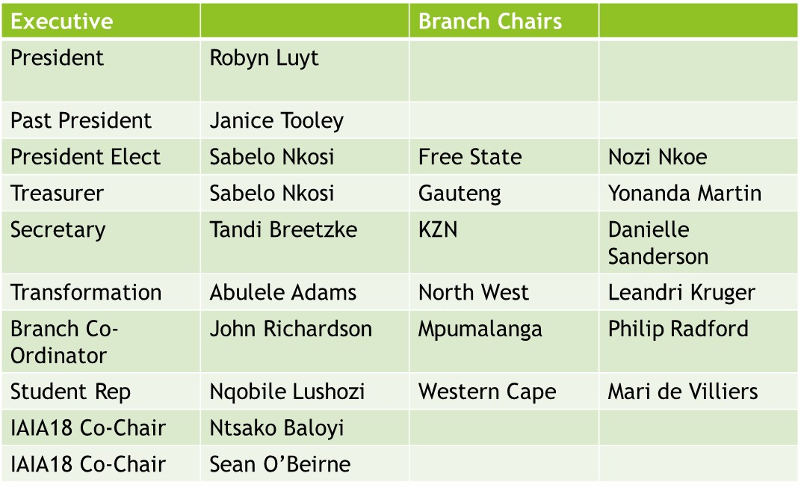  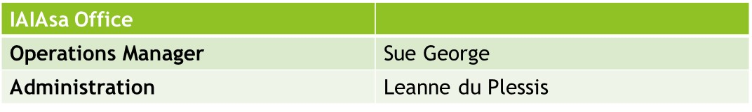
8. | Incoming President’s Address | Robyn thanked Janice Tooley for leading the organisation during her term as President. She also thanked:  - Jenny Mitchell – for her outstanding contribution to IAIAsa over many years.  - Kusasa Sithole: His remarkable contribution as student-representative, particularly in setting up one of IAIAsa’s flagship programmes, the ISMP.  - Mari de Villiers, with the assistance of Sabelo Nkosi: For successfully taking on the role of conference chair over and above her duties as WC branch chair.  - Paul Lochner and Nigel Rossouw: Hours of voluntary time to fulfil the role of IAIAsa2017 Programme Directors  - All branch committee members: for the hours of voluntary work they commit to produce quality branch events.  - IAIAsa members who volunteered their time and expertise this past year to assist and present at branch events, and all members for getting involved and attending events and conferences.  Robyn highlighted the IAIAsa mission, and indicated that the NEC had agreed to focus on the following strategic initiatives in the coming year:  - Transformation;  - Supporting Branches;  - Registration as a Voluntary Association with other organisations;  - Formalise existing alliances;  - Improve communication with members;  - Continue with ISMP;  - Focussed approach to branding and marketing;  - Focus on organisation of IAIA18; and  - Continued improvement of operations through streamlining processes and systems.  Robyn appealed for input from members to facilitate growth and benefits.
9. | Proposed Amendments to Constitution | The following amendments to the Constitution were proposed:  - After 4.1 insert the following:  4.1.1. apply the assets and income of the Association, however derived, solely towards the furtherance of its main objectives and in a manner consistent with this Constitution.  - After 4.1.4 insert the following:  4.1.5. recognise restricted income where funds are received with specific conditions set out regarding the use of these funds.  4.1.6. transfer any surpluses arising from annual operations to a capital reserve, to be used solely to fund the sustainability and growth of the Association. The capital reserve must be managed in accordance with an approved reserve policy.  - Renumber clauses 4.1.1 to 4.1.14  - After 4.9 add the following:  4.10. The capital reserves must be analysed and presented at the AGM. Any use of reserves must be motivated to members and approved at the AGM.  5.1.5 Honorary membership may be conferred on any person, by unanimous vote by the NEC, who has, in the opinion of the NEC, provided extraordinary services or has made extraordinary achievements for or in the name of the Association. Honorary Members shall be entitled to all the benefits of a Regular Member without payment of an annual membership fee.  - Renumber clauses 5.1.5 to 5.1.6  - Amend 6.5.7:  6.5.7 The term of office of members of the Branch Committees shall be in line with that of the NEC. To this end the Branch should hold its own AGM shortly before the national AGM, the Branch Committee election process must be concluded before financial year end.  - Amend 6.5.8  6.5.8 The financial accounts of the Branch shall form part of the accounts of IAIAsa. A Branch budget must be submitted to the NEC for approval within four weeks after the first NEC meeting of the financial year.  - Amend 6.6.5  6.6.5. The members of the Branch Committee shall serve a two-year term of office and may not serve more than two consecutive terms of office, unless he or she is elected to the position of Branch Chair.  - After 6.6.5 insert the following:  6.6.6 Notwithstanding the above, a Branch Committee Member’s term of office may be extended (for no more than a further two years), should the NEC determine such extension to be warranted.  - Amend 6.6.7:  6.6.7 The Branch Committee shall, from its members, choose a Branch Chairperson, a Branch Treasurer and a Branch Secretary. An individual must normally have served on the branch committee for at least a year before being eligible to act as Branch Chair.  - After 6.6.8 insert the following:  6.6.9 The term of office of the person who is elected as the Branch Chair shall automatically extended to cover such person’s time as Branch Chair for a period of two years, and Past Branch Chair for a period of one year.  - After 6.6.9 insert the following:  6.6.10 Where it is practically impossible for the anticipated succession of Branch Chair to occur as planned then the NEC may, by written resolution and for such instance only, amend the succession in exceptional circumstances.  - Renumber clauses 6.6.5 to 6.6.11
10. | IAIA18 | All focus in 2018 on International conference. Appeal to members to ensure that 30% of delegates will be South African and for people living in Durban to assist. Watch out for communication.
11. | Proposed change in financial year – The motivation for amending the financial year from 1 July to 30 June to 1 March to 28 February was put forward. The intention of the proposed change is to ring fence income and expenses in the same financial year.
12. | Proposed membership fee increases for 2018/19  If the proposed change in the financial year is approved, the next increase in membership fees will only be effected on 1 March 2019. The proposal is therefore to implement an increase of 9%.  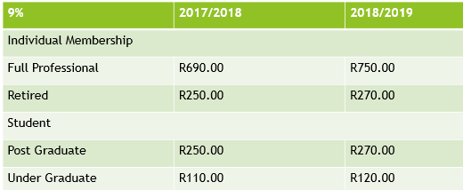
13 | Finances
- Proposed Budget 2017/18
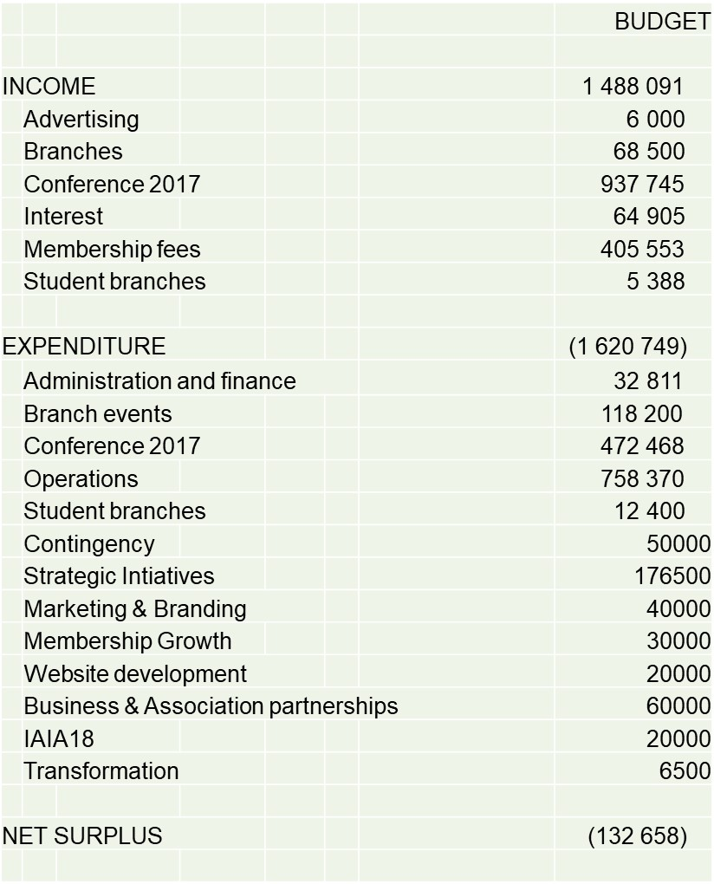

- Proposed Reserve Policy
- As an NPO IAIAsa transfers funds from annual operations into a capital reserve. The capital reserve must be used to fund sustainability and the growth of the organisation including programmes and initiatives undertaken for the benefit of members. These funds are recognised as unrestricted and must be used to fund the sustainability and future growth of IAIAsa.
- 3 reserve categories identified:
  - Sustainability reserve – This reserve must be protected, and any interest arising reinvested - R1,000,000 proposed as initial reserve amount.
  - General operational reserve – Amount equivalent to 6 months budgeted expenditure on recurring operational activities. To enable IAIAsa to absorb temporary downturns in income and cash flow fluctuations, without having to reduce operational expenditure - R495,890 proposed
  - Projects reserve – Made up of surplus reserve funds and can be used to fund specific strategic programmes - R136,071 proposed

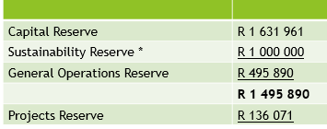

- Conditions proposed:
  - The Reserve must be analysed on a quarterly basis and presented to the NEC and reported on annually in the AFS.
  - The value of the Sustainability Reserve must be reviewed annually and approved by members at the AGM. A request to use Sustainability Reserve may be made to members during the course of a year via electronic ballot.
  - The General Operations Reserve requirement must be budgeted for on an annual basis and presented to members for approval at the AGM
  - Any use of the Projects Reserve must be motivated to members and approved at the AGM or via electronic ballot

11. | Items for Adoption and Approval | a. Adoption of Annual Financial Statements  Proposer: Paul Lochner  Seconder: John Geeringh  b. Appointment of Accounting Officer for 2017/2018:  Proposer: Kim Pontac  Seconder: Nigel Rossouw  c. Appointment of Bankers for 2017/2018  Proposer: Amanda van Reenen  Seconder: Barry Wiesner  d. Appointment of Signatories for 2017/18  Proposer: Percy Langa  Seconder: Lauren Elston  e. Approval of change of financial year  Proposer: Katherine Wiles  Seconder: Lynn Whittington-Jones  f. Adoption of membership fee increase effective 1 July 2018  Proposer: Peter Wood  Seconder: Marc Hardy  g. Adoption of amendments to the Constitution  Proposer: Melissa Groenink  Seconder: Bryony Walmsley  h. Approval of Budget 2017/18  Proposer: John Geeringh  Seconder: Lauren Elston  - Adoption of Reserve Policy  Proposer: Terry Calmeyer  Seconder: Francios Retief  j. Approval of use of project reserves 2017/18  Proposer: Kim Pontac  Seconder: Nigel Rossouw
12. | Other items from the floor | - Nigel Rossouw raised the costs of attending IAIA18 if the fees were US$ based fees. He requested a special provision for RSA and IAIAsa delegates. Sean O’Beirne responded by advising that all efforts would be made to do this, and that IAIAsa was currently in negotiations with IAIA in respect of options available to maximize Southern African delegates. It would however be dependent on sponsorship.  - Members were reminded to complete the survey.  - Jenny Mitchell’s role and input was reflected upon and the legacy contribution she had made. While she was leaving the NEC, she was awarded IAIAsa honorary membership.
13. CLOSURE |  | Sean O’Beirne thanked all for their participation and closed the meeting at 12:13

