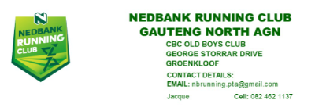
NEDBANK RUNNING CLUB GAUTENG NORTH (PRETORIA) COMMITTEE 2022
2022 COMMITTEE | NAME & SURNAME | 2023 NOMINATION
Chairperson | Jacqueline Rencontre
Co Chair & Treasurer | Francois Venter
Administrator | Jacqueline Rencontre
Secretary | Zander Goold
Development, Amandasig | Tumelo Mabua
Time Trials & Admin, Amandasig | Lifutso Mabua
General Member | Enock Skosana
General Member | Frances van Blerk
General Member | Ingrid Koster
General Member | Michael Lenhoff

NEDBANK RUNNING CLUB GAUTENG NORTH (PRETORIA) AGM
2023 COMMITTEE NOMINATION FORM

Annual General Meeting – 26 January 2023
Committee Nomination

I …………………………………………… (Your name & surname)

hereby nominate ………………………………. (Name & Surname of person)

as ………………………….. (Position) - Ensure you have contacted the person you would like to nominate and that they are willing to stand on the Committee

……………………………………… (Can be digitally signed by adding Name & Surname)

………………………………………..…… (Your email) ……………………………… (Cell No)

Signed at ……………………………… (Place) on ______/______ 202..

