NEDBANK RUNNING CLUB GAUTENG NORTH (PRETORIA) MEMBERSHIP QUERIES
Thank you for your email query to be part of Nedbank Running Club Gauteng North (Pretoria).
Please find our pamphlet below with all the information you will need as well as our Kit order form below.
I also attached the 2024 ASA Form that needs to be filled out on the EXCEL document and sent back to me with your proof of payment to ensure your registration is completed. No need to print and sign the form, just fill in the document and send it back to me.
LINK TO 2024 ASA FORM - https://eolstoragewe.blob.core.windows.net/wm-11330-cmsimages/2024ASAPERMANENTLICENCEAPPLICATIONFORM.XLS
2023 Licenses are valid till end of Feb 2024 or until ASA sends out notice that you need to wear your 2024 ASA License. If you require a 2023 License till then, Membership including your ASA License will be R350.
If it is for a Junior Member, the relevant Birth Certificate need to be sent with the filled out ASA Form for us to issue a junior license.
2024 Club Fees are on our pamphlet below with our Club banking details. Please send us your proof of payment and filled out 2024 ASA form to complete your registration.
You can make payment including your membership and kit order. We hold limited kit stock at time trials on a Thursday.
LINK TO KIT ORDER FORM - https://eolstoragewe.blob.core.windows.net/wm-11330-cmsimages/NedbankRunningClubKitOrdersFormNov2023.xls

Remember to register on our Website www.nedbankrunningclub.co.za click the "REGISTER" button at the right hand side, choose Nedbank Gauteng North and click “NEXT” and fill out all your details to receive all communication from the Club and our National Newsletter.
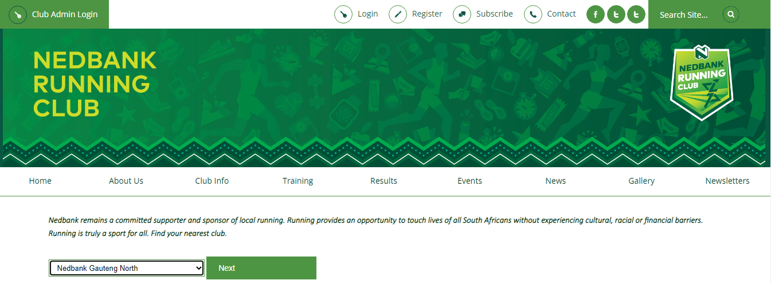
If you have any other questions, please do not hesitate to contact me and hope to see you at our Thursday Time Trials, we start at 17H30 promptly.

