5 things you need to know about ankle injuries

From risk factors to taping, here's the lowdown on running ankle injuries.
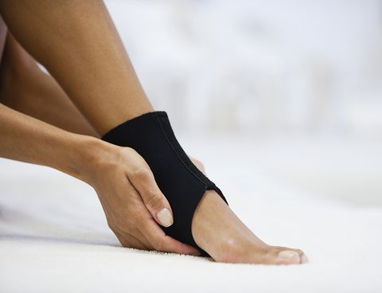
Ankles are easily neglected until something goes wrong with them, such as a sprain while trail running or a persistent ache after a race. We spoke to Ant Brightwell, physiotherapist at Ten Health & Fitness, to uncover the most important things runners need to know about their ankle health to avoid risking time on the side-lines.
1/ There’s more to ankle injuries than just sprains
While sprains are common ankle injuries, usually from a trip or fall, there are also problems runners can acquire through overuse. ‘What I see most are tendon problems, such as in the Achilles or tibialis posterior tendons,’ says Brightwell.
The tibialis posterior, or tib post, is a stabilising muscle in the lower leg, which wraps behind the ankle bone and supports the arch of the foot – if its tendon is inflamed, this area may feel tender or achy before becoming painful. Left untreated, an injured tib post tendon can become unable to support the arch of the foot and lead to fallen arches – not good.
The Achilles tendon, which you may be more familiar with, is the thick tendon that runs from your heel, over your soleus (the long, deep calf muscle) up to the gastrocnemius (the upper, rounded calf muscle). Tendon problems in the Achilles can present as tenderness or thickening, with a notable physical symptom according to Brightwell: “Typically, you have a tendinopathy then you get this sort of egg formation, like a Cadbury’s mini egg – the tendon will be nice and thin and then there’ll be a hard lump, and then it goes back down to normal size.”
2/ Certain people are at greater risk of ankle injuries
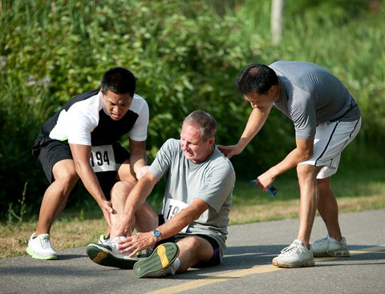
Runners who’ve had ankle injuries in the past may be all too aware that they can be prone to further injuries: “If you’ve had an ankle injury before and it’s not been rehabbed to 100% then it would be a predisposing factor,” explains Brightwell. “A common mistake that many people make is to stop rehab too soon. They assume that just because they’ve got back to the stage where they’re pain-free, that this means that the injury is now 100% recovered – when in fact, it isn’t.”
Additionally, office workers can be in trouble: “If you’ve got a very busy but sedentary work life with long hours but at a desk, that ends up switching off a lot of postural muscles, which has a huge influence on your leg alignment.”
Luckily, there are a few ways you can tell whether you have ankle instability or weakness, so you can prehab before you hit an injury-related roadblock. “Look at the wear pattern on your shoe – if there’s a discrepancy on where the shoe is wearing down on the left and right then it shows you’re running slightly differently on each side which could be a sign that you’re unstable,” Brightwell says. “Also, if you have lots of mini twists – where you’re walking down the street and find you almost twist your ankle but not quite, that’s definitely a sign that the muscles on the inside and/or outside are slightly too weak and you’re leaning on your ligaments a bit more.”
Try comparing calf raises on each side when at home or at the gym. “See how high can you go on one leg, then do double leg calf raises and see if there’s a tendency to lean on one leg more. Does one hurt, feel weak or feel tight? Can you do the same amount on each leg?”
(Related: How strong are your lower legs?)
Additionally, put your single leg balances to the test and see if you’re wobblier on one side. “Sometimes you might not see a difference instantly but if you look at your endurance through that exercise you’ll notice a difference. So you might find you can hold your balance a minute and a half balancing on one leg, but on the other leg you’re not stable for more than 10 seconds – a great indicator of an inherent weakness or instability.
3/ Running with an ankle injury can cause you to develop more injuries elsewhere
Taking a break from training while injured can be a struggle, so dashing back to your runs after an ankle injury is totally understandable. However, continuing to train before your ankle muscles and ligaments have been rehabbed can lead to more injuries down the line. “Something I find people often overlook in the picture of ankle instability is something like IT band syndrome – feeling something higher up because again you’re trying to compensate for the ankle,” explains Brightwell. That means that if you’ve got a persistent overuse injury in your knee or hip joint and prescribed glute activation exercises aren’t helping, the cause could be further down.
Similarly, if you train too much with an injury higher up the leg, that can lead to ankle problems developing. “In trying to offload that injury because it’s too painful, such as by trying to keep the weight on the other leg or pushing through the foot of the injured leg in a compensatory way instead of bending the knee, people can load one foot too much.” This can cause overuse injuries in the ankle such as the Achilles and tib post mentioned above.

4/ Don’t go overboard with taping
“This is where I get into lots of arguments with other physios!” says Brightwell. “I’m against taping long term.” Obviously, in some situations strapping tape is just what you need. “If someone comes in and they’re in a lot of pain then taping will obviously stabilise the ankle. Or if you’ve got a ligament strain or a muscle you need to take the pressure off, then again it’s exactly what you need.”
However, if you never run without taping up first, problems can arise. “If you do it for too long, you’re taking away the function of a lot of the tissue in that ankle – not even necessarily the injured tissue. If you’ve ever broken something and had it in a cast, when you take the cast off the muscles have wasted away because they’ve not been needed. That’s the same if you strap up the ankle for too long.”
5/ Rehab ankle injuries thoroughly
On top of any specific exercises your physio has prescribed for your ankle injury, Brightwell says well-performed calf raises are excellent for strengthening the ankle joint. “Ideally your heel and ankle should be coming up in a straight line,” he advises. If you’re an over-pronator, you can be prone to your feet rolling in as you rise, so keep an eye on your technique in a mirror. In addition to calf raises, Brightwell recommends working on your technique for more global leg exercises like squats and lunges.
Remember, being able to complete a certain amount of exercises doesn’t necessarily mean you’re ready to run again. “You may be able to perform a very simple calf raise properly - but that’s very different from running, landing on one-foot, absorbing pressure from the uneven ground or the gradient and pushing off again. It’s very different going from a controlled environment [with calf raises and other physio exercises] back to the habitual movement pattern [running].”

