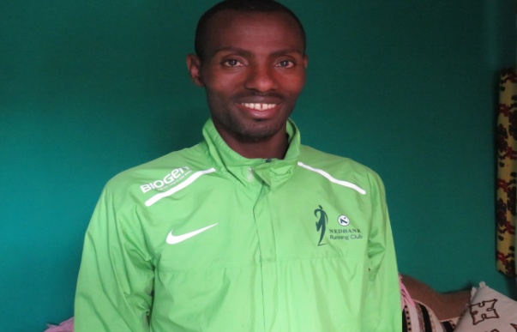

1 Agaro Adula Ruke
Passport no EP5375994
DOB 16 NOV1994

Awasa Marathon 10 June 2018 2:14

Changsha International Marathon 2019-10 -30 2:19

