Murray & Roberts Running Club
22 Skeen Boulevard, Bedfordview, 2007, South Africa
Cell: +2776 578 4466
E-mail:dana.coetzee@murrob.com | Web: www.murrob.com
ENGINEERED EXCELLENCE
Profile of Caroline Josten
Date of Birth: 24/10/1980
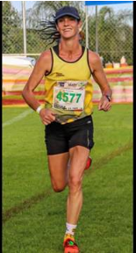
- 2019 KaapseHoop Marathon: Champion – 2:48:13
- 2019 RAC 32km Tough One: Top 10 Finisher
- 2020 Johnson Crane 21km: 3rd Position – 1:25:31
- 2020 Cape Peninsula Marathon: 5th Position – 2:53:39
- 2020 Om die Dam 50km: Champion – 3:33:38

