Murray & Roberts Running Club
22 Skeen Boulevard, Bedfordview, 2007, South Africa
Cell: +2776 578 4466
E-mail:dana.coetzee@murrob.com | Web: www.murrob.com
ENGINEERED EXCELLENCE
Profile of Charne Bosman
Date of Birth: 06/11/1975
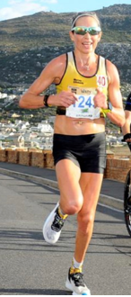
· 2016 Comrades Marathon: Champion
· 2017/2018/2019 RAC 32km Tough One: Champion
· 2018/2019 Comrades Marathon – Gold Medallist
· 2018/2019 Two Oceans Marathon – Gold Medallist
· 2019 Om die Dam 50km: Champion
· 2019 Johnson Crane Marathon: Champion – 2:44
· 2020 Cape Peninsula Marathon: 2nd Position - 2:48:27
· 2020 Sanlam Cape Town Invitational Marathon: 1st Position (Pretoria) – 2:56:18
· 2021 African X: 1st Position – Mix Team

