Murray & Roberts Running Club
22 Skeen Boulevard, Bedfordview, 2007, South Africa
Cell: +2776 578 4466
E-mail:dana.coetzee@murrob.com | Web: www.murrob.com
ENGINEERED EXCELLENCE
Profile of Cobie Smith
Date of Birth: 11/01/1985
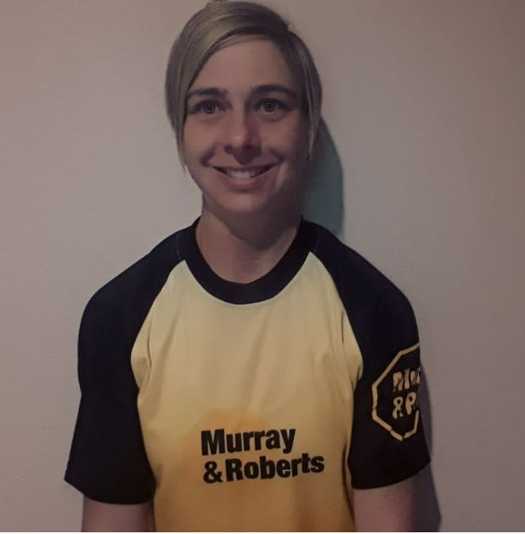
- 2018/2020 Om die Dam 50km: 2nd Position
- 2018 Comrades Marathon: Sub 7:30 – 7:21:29
- 2019 Edenvale Marathon: Champion – 2:54
- 2019 Loskop 50km: 2nd Position – 3:28
- 2019 KaapseHoop Marathon: 3rd Position – 2:54
- 2019 RAC 32km Tough One: 6th Position
- 2020 Johnson Crane Marathon: Champion – 2:59
- Win several road races Nationwide
- Represented South Africa at the IAU Africa 50km Championships in Nigeria

