Murray & Roberts Running Club
22 Skeen Boulevard, Bedfordview, 2007, South Africa
Cell: +2776 578 4466
E-mail:dana.coetzee@murrob.com | Web: www.murrob.com
ENGINEERED EXCELLENCE
Profile of Danette Smith (Walley)
Date of Birth: 13/12/1988
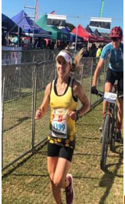

- 2014 South African Long Distance Trail: Champion
- 2017 South African Marathon (42,2km): Champion
- 2017 Comrades Marathon: 8th Position – 6:58:38
- 2020 Western Province Marathon (42,2km): Champion
- 2020 Sanlam Cape Town Invitational Marathon: 5th Position (Cape Town) – 2:59:31
- 2021 African X: 1st Position – Open Ladies
- Win several road and trail races Nationwide
- Represented WPA province several times

