Profile of David Gatebe
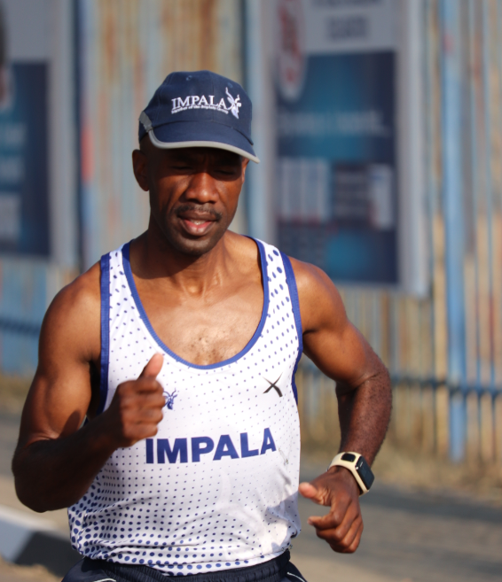

Date of Birth | 1981-08-13
Nationality | South African
YEAR | RACE | PLACE | DISTANCE | TIME
2020 | Battle of Sports | Noord Kaap | 200km | 2 Days 8 Hours
2019 | Two Oceans | Cape Town | 56 Km | 3:09
2019 | Comrades | Durban | 90 Km | 6.00
2018 | Two Oceans | Cape Town | 56 Km | 3.11

