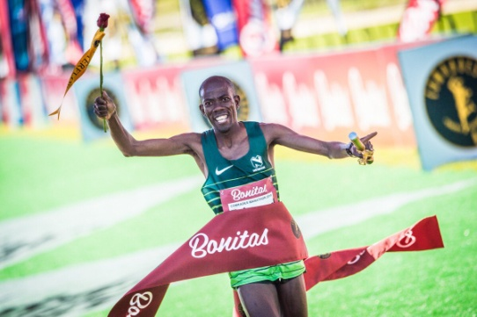

CURRICULUM VITAE: EDWARD MOTHIBI

PERSONAL DETAILS
FIRST NAME / SURNAME: Edward Mothibi
DATE OF BIRTH: 10 November 1984
CLUB: Nedbank Running Club
NATIONALITY: South African

PERSONAL BEST TIMES
Distance Time Venue Year 21km 1:04 P.E RSA 2010
Marathon 2:13:54 Cape Town RSA 2021
50km 2:45:26 P.E RSA 2022
Comrades 5:17:34 Durban RSA 2023
Two Oceans 56km 3:22 Cape Town RSA 2017

Best Performances 2025
Pretoria Marathon, 2:30:05, 3rd

Best Performances 2024
Comrades Marathon (Down Run), 5:44:09, 16th
Tshwane North Ultra (RSA) 50km, 3:37:08, 16th
Soweto Marathon, 2:27:00

Best Performances 2023
Nedbank Runified 50km 2:50:26, 13th
Comrades Marathon (Down Run), 5:17:34, 3rd
Phobians 15km, 50:33, 2nd
Brooklyn 32km, 1:51:29, 3rd
Sanlam Cape Town Marathon, 2:14:23

Best Performances 2022
Nedbank Runified 50km 2:45:26, 3rd
Comrades Marathon (Down Run), 5:33:46, 2nd

Best Performances 2021
Nedbank Runified 50km 2:47:02, 10th
Cape Town Marathon, 2:13:54, 13th

Best Performances 2020
Nedbank Runified 50km 2:47:02, 10th
Intercare Classic (agn) 21km 1:07:41, 2nd
Cape Town Marathon (Potch Race) 2:16:48, 1st

Best Performances 2019
Intercare Classic 21km 01:09:31, 2nd
Om die Dam 50km, 3:05:53
Comrades Marathon, 5:31:33, 1st
IAU 50km World Champs Romania, 2:49:49, 5th

