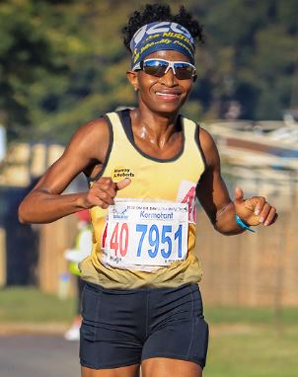
Enie Manzini
Date of Birth: 25/10/1980
- 2019 Johnson Crane 42,2km Marathon – 4th Position – 3:00:36
- 2019 Irene 48km Ultra Marathon – Champion – 3:30:00
- 2019 Comrades Marathon – Top 20 Finisher – 7:10:51
- 2020 Dubai International 42,2km Marathon – 2:56
- 2021 CGA 21,1km Championships – 4th Position = 1 23:31 (1st Veteran Lady)
- 2021 SA 21,1km Championships – 1:21:25

