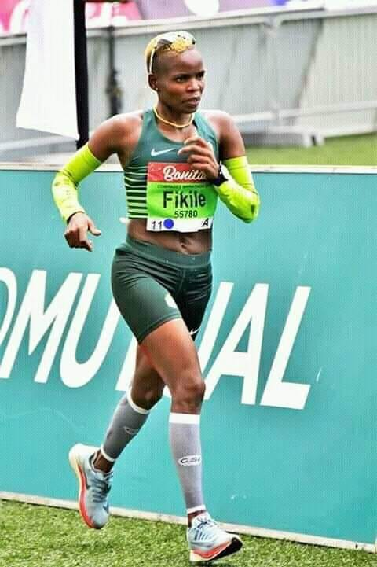

CURRICULUM VITAE: Fikile Mbuthuma

PERSONAL INFORMATION
FIRST NAMES / SURNAME: Fikile Mbuthuma
DATE OF BIRTH: 23 December 1980
CLUB: Nedbank Running Club KZN
NATIONALITY: South African

Personal Bests
Event Result Venue Date
Marathon 2:58:02 East London (RSA) 2015
50km 3:42:14 Port Elizabeth (RSA) 2022
100km 7:59:17 WMA, Sveti Martin (CRO) 2018

Comrades Marathon Results
2023 Down, 06:50:19, 19th
2019 Down, 07:24:48, 29th
2018 Down, 06:54:36, 12th
2017 Up, 07:14:34, 14th
2016 Down, 06:52:32, 8th
2015 Up, 07:18:41, 15th
2014 Down, 07:08:26, 12th
2013 Up, 07:38:53, 16th

Best Performances 2024
Richards bay marathon time, 3:03, 1st
Hillcrest Half Marathon, 1:27, 2nd
Cape Peninsula Marathon, 3:10 11th
Harry Gwala Marathon, 3:09, 6th

Best Performances 2024

Best Performances 2023
Comrades Marathon 87km, 6:50:19, 19th
Durban International Marathon (RSA) 3:01:54

Best Performances 2022
Nedbank Runified 50km, 3:42:14, 10th

Best Performances 2019
IAU 50km WC Brasov (ROU) 50km 3:47:15, 39th
Comrades Marathon - Up Run (RSA) 87km 7:24:48, 29th
Two Oceans Marathon (RSA) 56km 4:32:43, 41st

Best Performances 2018
East London (RSA) Marathon 2:58:02
WMA 100km, Sveti Martin (CRO) 100km 7:59:17, 10th
Two Oceans Marathon (RSA) 56km 4:16:51 25th

Best Performances 2017
Durban (RSA) Marathon 3:01:44

Best Performances 2016
East London (RSA) Marathon 3:08:23

