41 the Boulevard, Westend Office Park, Spine Road, Westville, 3610. Tel: 031-2757000
National Club Manager: Rhyn Swanepoel, Cell: 0764569733, Email: rhyn.swanepoel@gmail.com

Gladwin Mzazi PROFILE

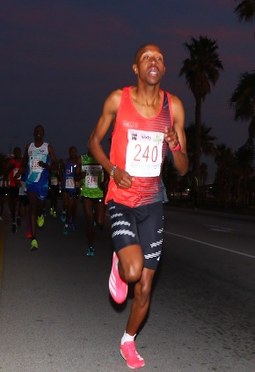

Personal Best
Half Marathon | 1:01:12 |  | New Delhi (IND) | 15 DEC 2013 |  | 11:43
Marathon | 2:17:43 |  | Fukuoka (JPN) | 07 DEC 2014 |  | 10:28

