Is It Harmful to Heel Strike When Running?
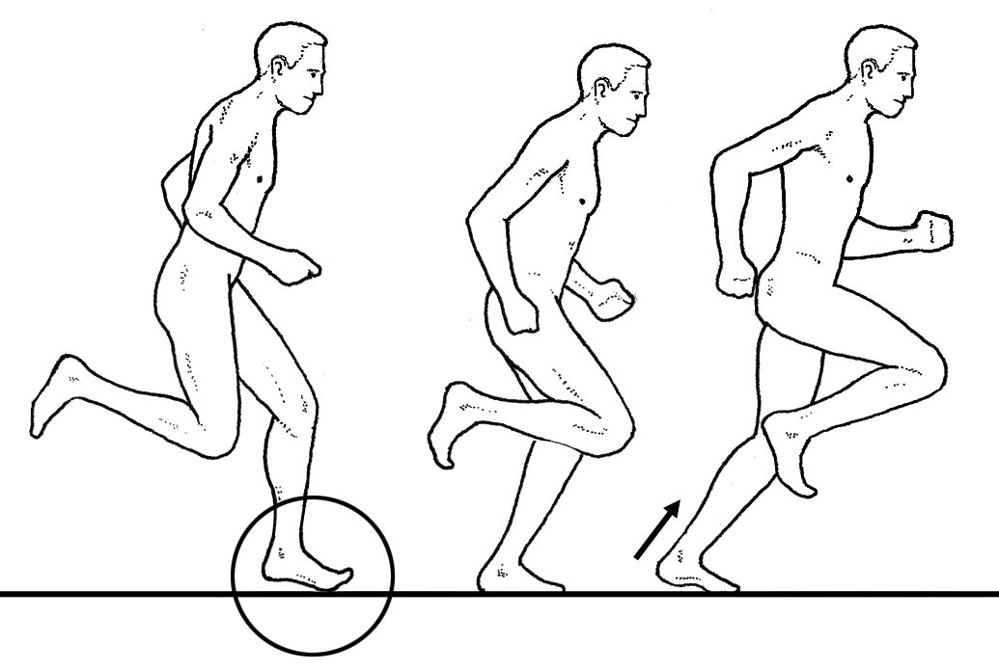
Even though 95 percent of runners instinctively strike the ground with their heels, there is a growing trend among running experts to have lifelong heel strikers convert to a more forward contact point. The switch to a mid and/or forefoot strike pattern is supposed to reduce impact loads and enhance the storage and return of energy in our tendons (making us faster and more efficient, as demonstrated in the illustration above). The theory is that because we’ve had our feet protected by shoes for so long, we’ve recklessly started landing on our heels because we could no longer sense the dangerous impact forces associated with heel striking. By reverting to a more natural midfoot strike, we will avoid injury and run more efficiently.
Although appealing, the belief that switching to a mid or forefoot contact point will alter injury rates and improve efficiency has never been proven. Research evaluating injury rates associated with different contact points in more than 1600 runners has shown no difference in the incidence of running-related injuries between rearfoot and forefoot strikers (1-3). Advocates of midfoot strike patterns will cite a frequently referenced study published in Medicine and Science in Sports and Exercise showing that runners making initial contact at the midfoot have 50 percent reduced rates of injuries (4). The problem with this study is that the 16 runners involved were all Division I college runners who self-selected a midfoot strike pattern.
While self-selecting a midfoot strike pattern is fine and is often the sign of a high-level athlete, it’s the conversion of a natural heel strike runner into a midfoot strike runner that causes trouble. In my experience, the world’s fastest runners who self-select midfoot strike patterns tend to be biomechanically perfect, with wide forefeet, neutral arches, and flexible calves. Over the past 30 years, I’ve noticed that flat-footed recreational runners who attempt to transition to forefoot strike patterns tend to get inner foot and ankle injuries such as plantar fasciitis and Achilles tendinitis, while high-arched runners attempting to transition to a more forward contact point frequently suffer sprained ankles and metatarsal stress fractures.
RELATED: Reduce Injury Risk With A Stronger Core
The reason that runners with heel versus mid/forefoot strike patterns get different injuries is because they absorb force in different areas. In a detailed study evaluating the biomechanics of habitual heel and forefoot strike runners, researchers from the University of Massachusetts demonstrate that runners who strike the ground with their forefoot absorb more force at the ankle and less at the knee (5). The opposite is true for heel strikers in that they have reduced muscular strain at the ankle with increased strain at the knee.
This is consistent with several studies confirming that the choice of a heel or midfoot strike pattern does not alter overall force present during the contact period, it just transfers the force to other joints and muscles: mid- and forefoot strikers absorb the force in their arches and calves, while heel strikers absorb more force with their knees. This research proves that choosing a specific contact point does not alter overall force, it just changes the location where the force is absorbed. This is the biomechanical version of “nobody rides for free.”
Research evaluating the metabolic cost of running also shows no clear advantage for a more forward contact point. In fact, most studies suggest the vast majority of recreational runners are significantly more efficient with a heel-first strike pattern. In a detailed paper published in the Journal of Experimental Biology, scientists calculated joint torque, mechanical work performed, and muscle activity associated with altering initial contact points at various speeds of walking and running (6). The results of this study confirmed that walking with a heel-first strike pattern reduced the metabolic cost of walking by a surprising 53 percent. That’s a huge difference in efficiency and it explains why almost all slow joggers (who often run just a little faster than walking pace) make initial ground contact with their heels. This contrasts with studies showing that as many as one-third of the world’s fastest distance runners strike the ground with their midfoot (7).
RELATED: Sole Care: How Runners Can Reduce Foot Injuries
The big question is, since fast runners are equally efficient with either a heel or midfoot contact point, while most recreational runners are more efficient with a heel-first strike pattern, at what speed does a heel contact lose its metabolic advantage? In a computer simulated study evaluating efficiency, researchers from the University of Massachusetts showed that while running at 7:36 per mile pace, heel striking was approximately 6 percent more efficient than mid or forefoot striking (8). Some recent research suggests that the 6:25 per mile pace is the transition point at which there is no difference in economy between heel and midfoot strike patterns (9). These studies confirm that although highly skilled runners are efficient while landing on their mid or forefeet, the majority of recreational runners are more efficient with a heel-first strike pattern.
Given the clear metabolic advantage associated with heel striking at all but the fastest running speeds, it’s not surprising that when asked to rate comfort between heel and midfoot strike patterns, recreational runners state that a rearfoot strike pattern is significantly more comfortable (10). Improved efficiency also explains why approximately 35 percent of runners transitioning into minimalist footwear continue to strike the ground with their heels despite the amplified impact forces: heel striking is too efficient to give up (11).
The bottom line is that before you consider switching from a heel to a midfoot strike, make sure that it’s clinically justified. Because midfoot strike patterns significantly reduce stress on the knee, they should be considered for all runners suffering with recurrent knee pain. This is especially true for faster runners with wide forefeet and flexible Achilles tendons. Conversely, runners with a history of Achilles, forefoot, and/or plantar fascial injuries should almost always make initial contact along the outside of the heel, because contrary to what many running experts say, striking the ground heel first is safe and efficient. The ninety-five percent of runners who naturally select a heel-first strike pattern can’t all be wrong.

