Murray & Roberts Running Club
22 Skeen Boulevard, Bedfordview, 2007, South Africa
Cell: +2776 578 4466
E-mail:dana.coetzee@murrob.com | Web: www.murrob.com
ENGINEERED EXCELLENCE
Profile of Janie Grundling
Date of Birth: 28/12/1979
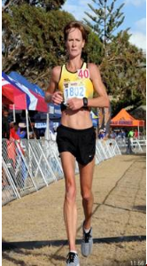
- 2017 Two Oceans 56km: 7th Position – 4:03:51
- 2018 Two Oceans 56km: 13th Position – 4:03:24
- 2019 Two Oceans 56km: 16th Position – 4:04:21
- 2019 Comrades Marathon: 21st Position – 7:17:49
- 2019 RAC 32km Tough One: 4th Position
- 2020 Johnson Crane Marathon: 3rd Position
- 2020 Cape Peninsula Marathon: 4th Position – 2:50:53
- 2020 Sanlam Cape Town Invitational Marathon: 4th Position (Cape Town)
- Represented South Africa at the Southern Regions 21km – Namibia
- Win several road races Nationwide

