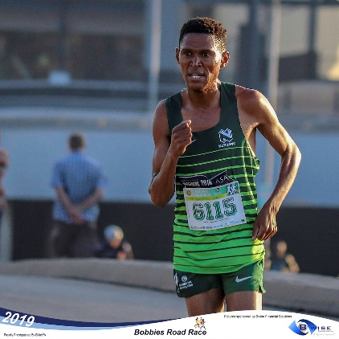

CURRICULUM VITAE: Joel Mmone

PERSONAL DETAILS
FIRST NAME / SURNAME: Joel Mmone
DATE OF BIRTH: 29 Mar 1991
CLUB: Nedbank Running Club
NATIONALITY: South Africa

PERSONAL BEST
Event Result Place Date
5000m 14:02.05 Potchefstroom (RSA) 2016
10000m 28:49.92 Durban (RSA) 2017
10km 28:23 Casablanca (MAR) 2016
12km 34:35 Cape Town (RSA) 2018
15km 46:14 Pretoria (RSA) 2019
Half Marathon 1:01:22 Port Elizabeth (RSA) 2019
Marathon 2:21:34 Soweto (RSA) 2023

Personal Performances 2024
Nelson Mandela Bay Half Marathon, Gqeberha, 1:04:34, 7th

Personal Performances 2023
Nelson Mandela Bay Half Marathon, Gqeberha, 1:01:48, 9th
Run your City 10km Johannesburg, 29:59, 6th
Soweto Marathon, 2:21:34, 6th

Personal Performances 2021
Durban 10K CITYRUN, Durban RSA, 31:20
Nelson Mandela Bay Half Marathon, Port Elizabeth RSA, 1:04:56

