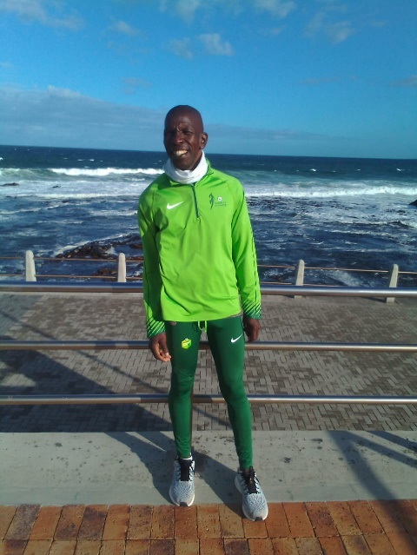

CURRICULUM VITAE: Johannes Makgetla

PERSONAL DETAILS
FIRST NAME / SURNAME: Johannes Makgetla
DATE OF BIRTH: 11 May 1982
CLUB: Nedbank Running Club
NATIONALITY: South African
EMAIL: Dave.adams.sa@gmail.com

PERSONAL BEST TIMES
Distance Time Venue Year
Half Marathon 1:13 Johannesburg 2021
Marathon 2:21:14 Cape Town 2021
50km 2:58 Mpumalanga 2019
Comrades 5:41 Durban 2022

Best Performances 2023
Comrades Marathon - Down Run (RSA) 87km, 5:23:34, 6th
50Km Nedbank Ultra Marathon Runified 50km, 2:50:56, 15th

Best Performances 2022
Comrades Marathon 5:41:36, 5th

Best Performances 2021
Sanlam Cape Town Marathon, 2:21:14

Best Performances 2020
Intercare Classic 21km, 1:16:26
Deloitte Marathon 42km, 2:39

Best Performances 2019
Sanlam Cape Town Marathon, 2:36
Loskop 50km, 2:58
Comrades Marathon, 6:25

