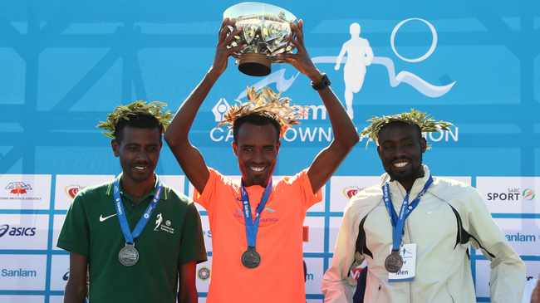
Ketema Bekele Negasa
- DATE OF BIRTH: 07 OCT 1986
- ATHLETE'S CODE: 14606450

2019 | 2:12:09 | Osaka (JPN) | 01 DEC 2019
2018 | 2:16:02 | Cape Town (RSA) | 23 SEP 2018
2017 | 2:11:07 | Cape Town (RSA) | 17 SEP 2017
2016 | 2:14:31 | Pyongyang (PRK) | 10 APR 2016
2014 | 2:11:17 | See Genezareth (ISR) | 10 JAN 2014
2013 | 2:13:23 | Omsk (RUS) | 22 SEP 2013
2012 | 2:14:58 | See Genezareth (ISR) | 12 JAN 2012

