CURRICULUM VITAE: Landie Greyling
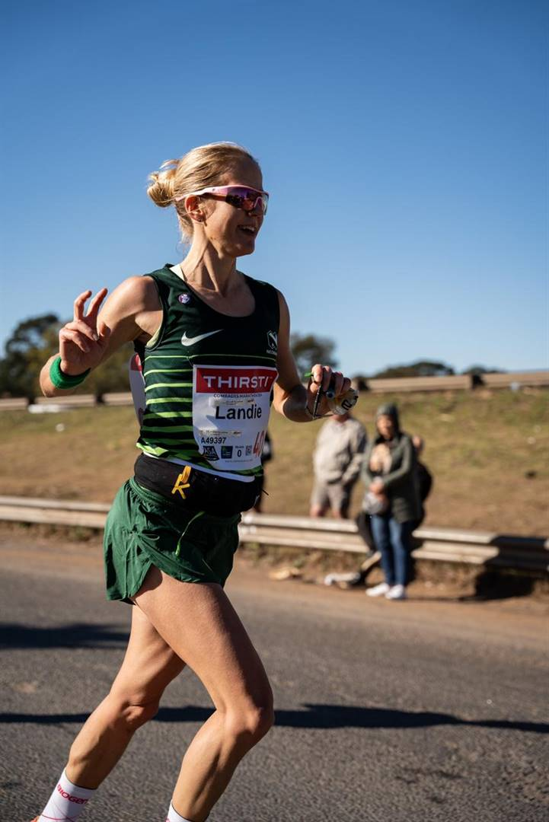

PERSONAL DETAILS
FIRST NAME / SURNAME: Landie Greyling
DATE OF BIRTH: 11 January 1984
CLUB: Nedbank Running Club
NATIONALITY: South African

Personal Best Time
Distance Time Venue Date:
Marathon 2:51:10 Cape Town (RSA) 2024

Best Performances 2025
Peninsula Marathon, 2:55:01, 3rd (SA Marathon Champ)
Two Oceans Marathon 56km, 3:57:38, 9th

Best Performances 2024
Cango Marathon, 2:51, 1st
Two Oceans, 4:11:23
Comrades Marathon, 6:40:46, 16th

Best Performances 2023
Merrell Whale of Trail (RSA) 53km, 5:43:25, 1st
World Mountain & Trail Running Championships 2023 (WMTRC) 45km, 5:43:36

Best Performances 2022
Ultra-Trail Cape Town (UTCT) 55 Km (RSA) 55km, 6:23:31, 1st
Cape Town Trail Marathon by Ryan Sandes (RSA) 46km, 5:24:24, 1st
Merrell Whale of Trail (RSA) 53km, 5:50:25, 1st
Ultra Trail Drakensberg - Giant’s Cup Uncut (GCU 62) (RSA) 62km, 6:43:04, 2nd

Best Performances 2021
SkyRun Lite 65 Km (RSA) 65km, 9:41:51, 1st

