Murray & Roberts Running Club
22 Skeen Boulevard, Bedfordview, 2007, South Africa
Cell: +2776 578 4466
E-mail:dana.coetzee@murrob.com | Web: www.murrob.com
ENGINEERED EXCELLENCE

Profile of Leilani Scheffer
Date of Birth: 23/05/1983
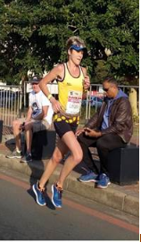
- 4 Times Rhodes Ultra Trail Run: Champion
- 2018/2019 Akasia Marathon: Champion
- 2017 Knysna Forest Marathon: Champion
- 2017/2018/2019 Two Oceans 56km Marathon: Top 20 Finisher
- Represented South Africa at the IAU Africa 50km Championships in Nigeria – (Bronze Medal)
- Win several road, trail and cross country races Nationwide
- Represented AGN province in cross country, 10km, 21,1km and 42,2km

